**CN**

**How do we get Internet from ISP?**

<https://www.youtube.com/watch?v=Rdw46zhn17E> 🡪 watch this.

Our home will connect to ISP thru a Modem/Router (router is used if we want to use wifi at home).

The Modem/router will have DHCP in it which gives IP to our home connected device.

The modem/router in turn will connect to street cabinet/box where all houses on street will connect to.

Now this will multiplex the data from all houses on street to ISPs place.

Now ISP will demux it and send the data to different sites as per requests.

ISP will also have a DNS with limited capability consisting frequently used sites.

Now, ISP will connect to Another such ISP for communication b/w two networks

**Internet**

**ISP-1 ISP-2**

Each ISP will have local connections given to houses at their sites.

Internet is again a Interconnection of different networks thru routers and switches.

Refer Top Down Network approach by kruose and ross.

**CN NPTEL (IIT KGP)**

N/w protocol stack + underlying technology will provide a mechanism for communicating with other systems.

L1 repeater/hub doesn’t divide collision domain.

Collisions will waste bandwidth.

Now L2 switch will divide Collision domains but all systems will be in broadcast domain.

L3 will separate n/w’s as per broadcast domain.

<https://www.cse.iitb.ac.in/~sri/cs348/>

<https://www.cse.iitk.ac.in/users/dheeraj/cs425/>

DNS, SNMP,ARP,DHCP are cross layer protocols. Generally ppl consider them as part of one of the layer but they are cross layer protocols i.e connect one layer with other.

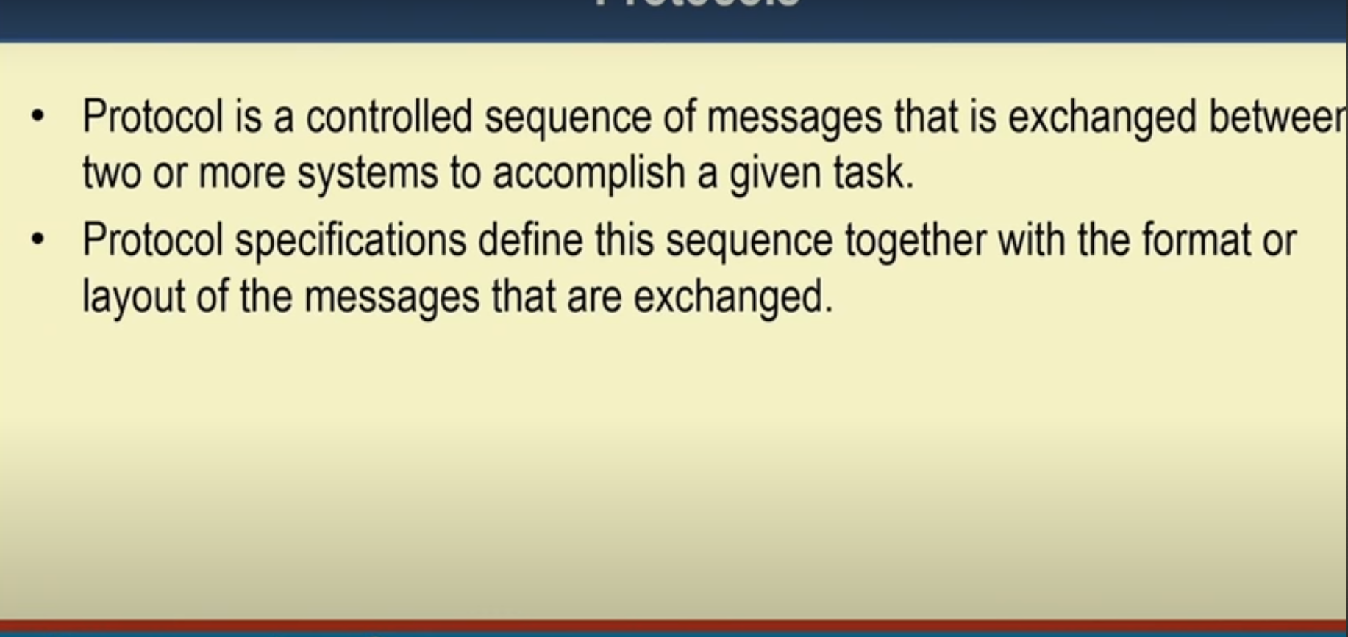

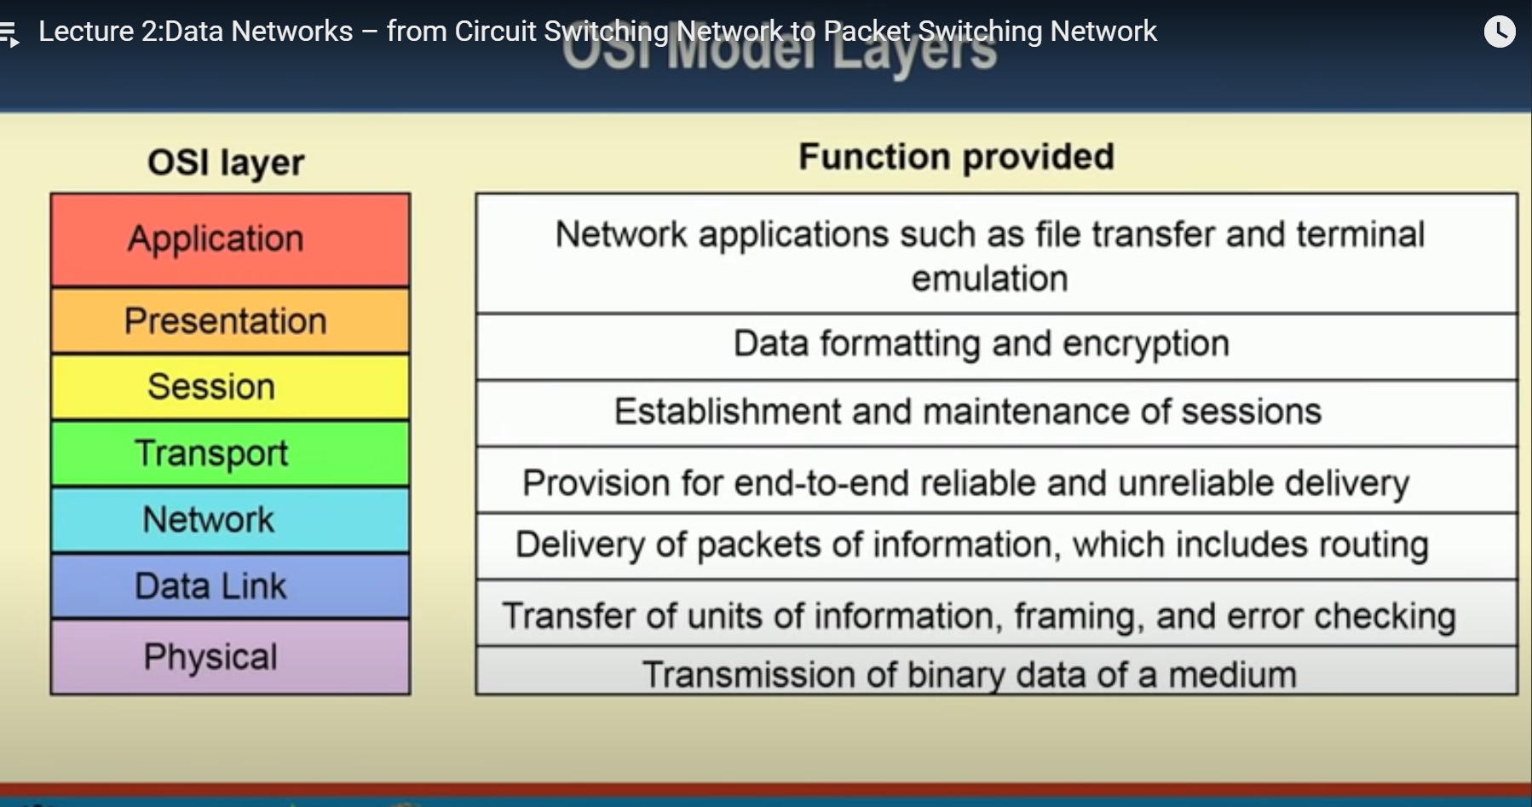

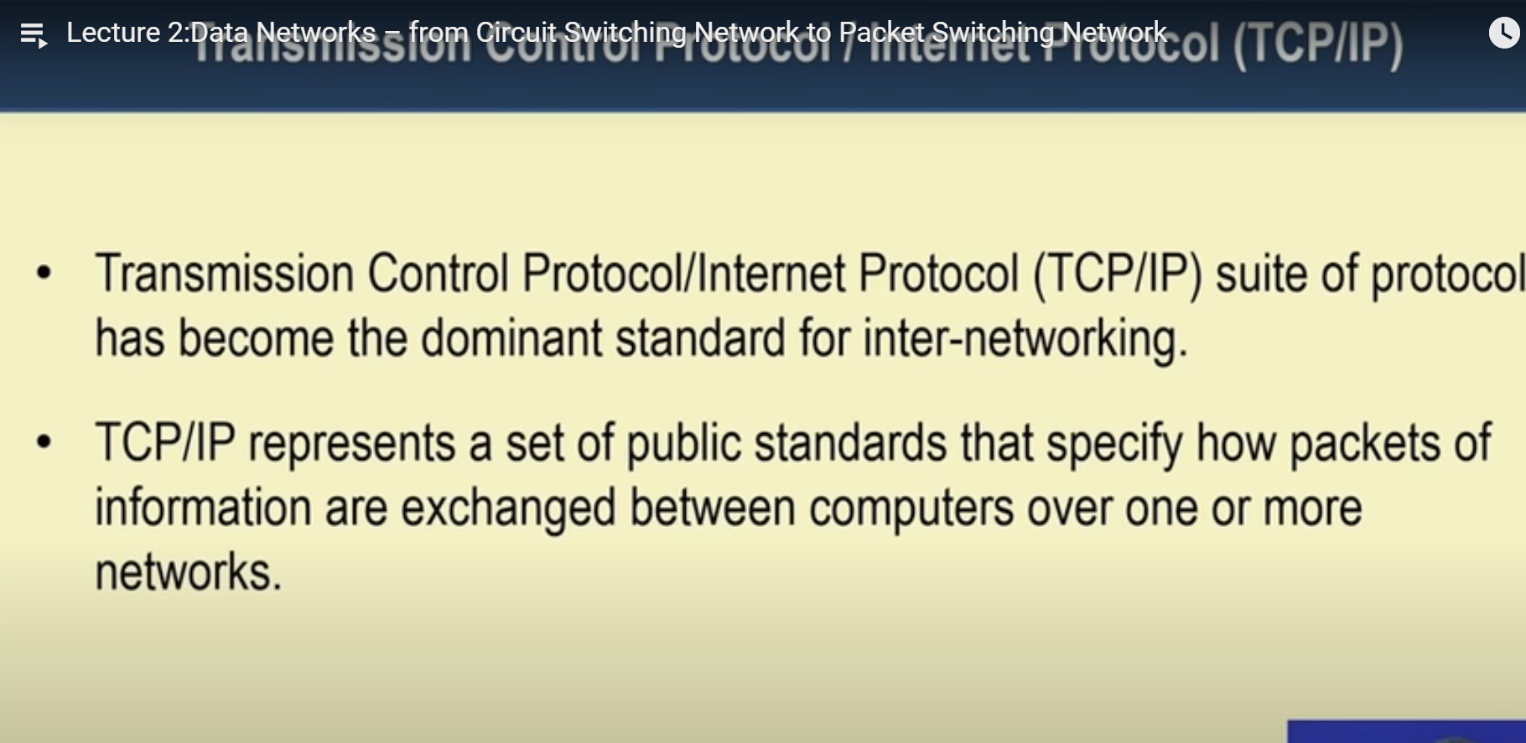

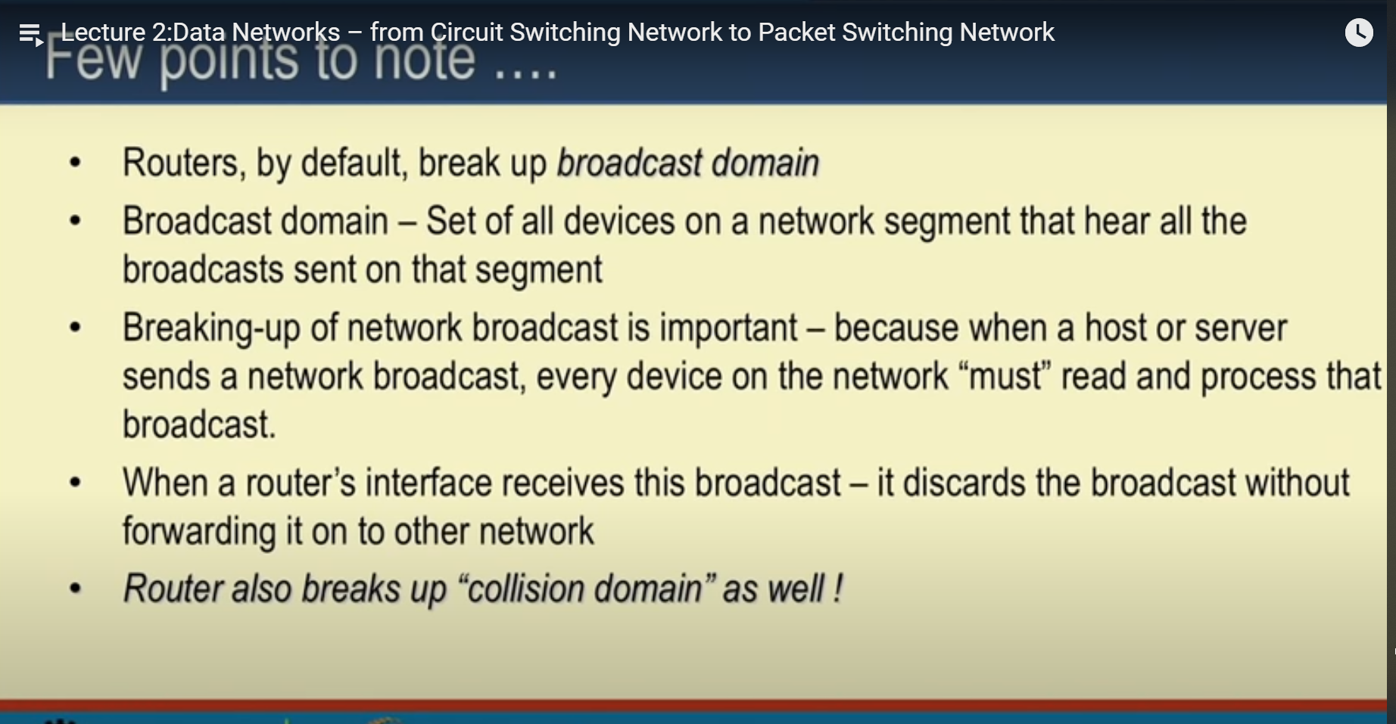

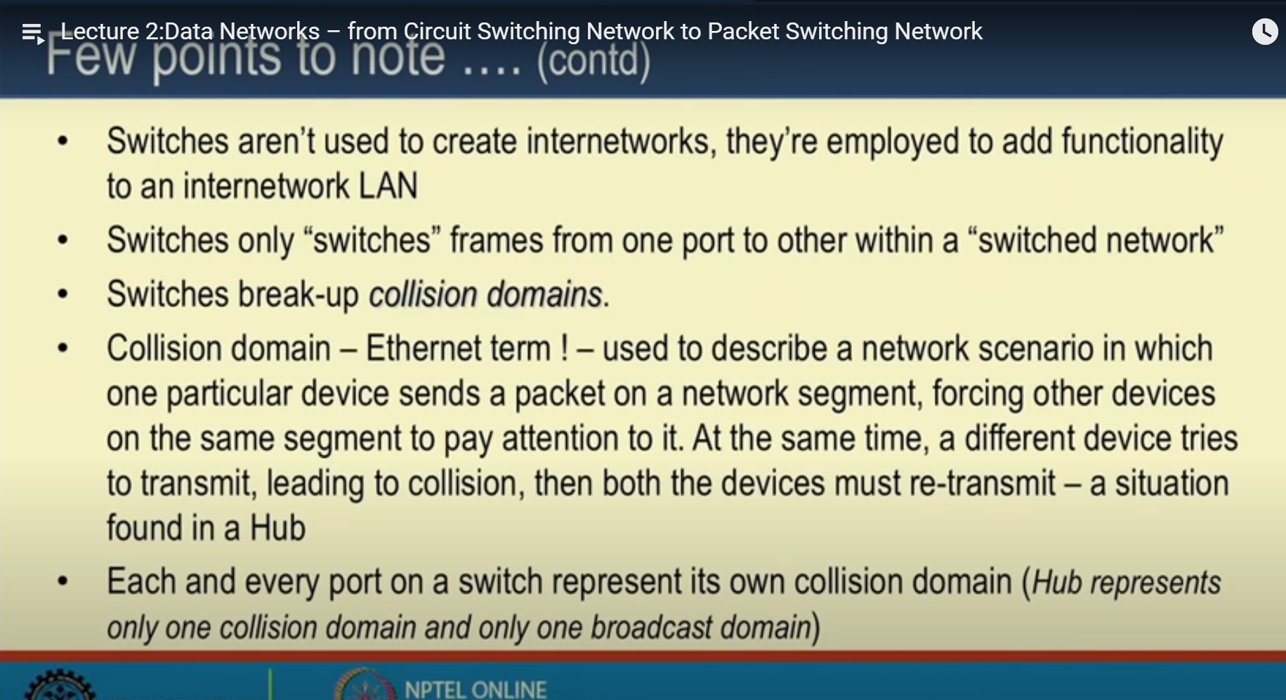

<https://www.cpe.ku.ac.th/~plw/dccn/presentation/ch08.pdf>

<http://www2.cs.uidaho.edu/~krings/CS420/Notes-F13/420-13-10.pdf>

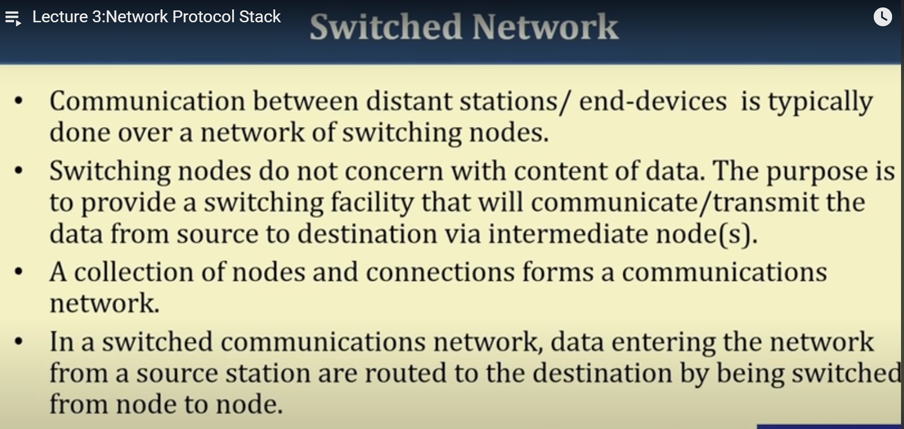

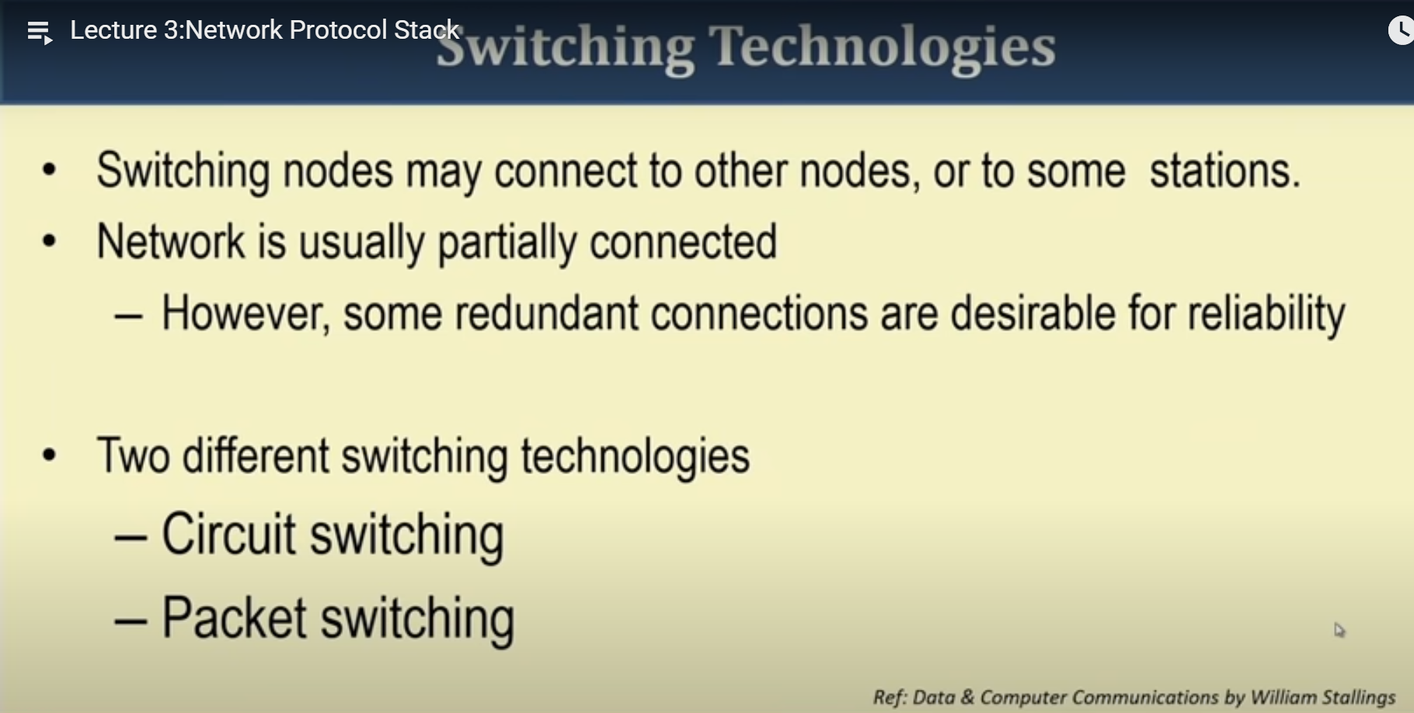

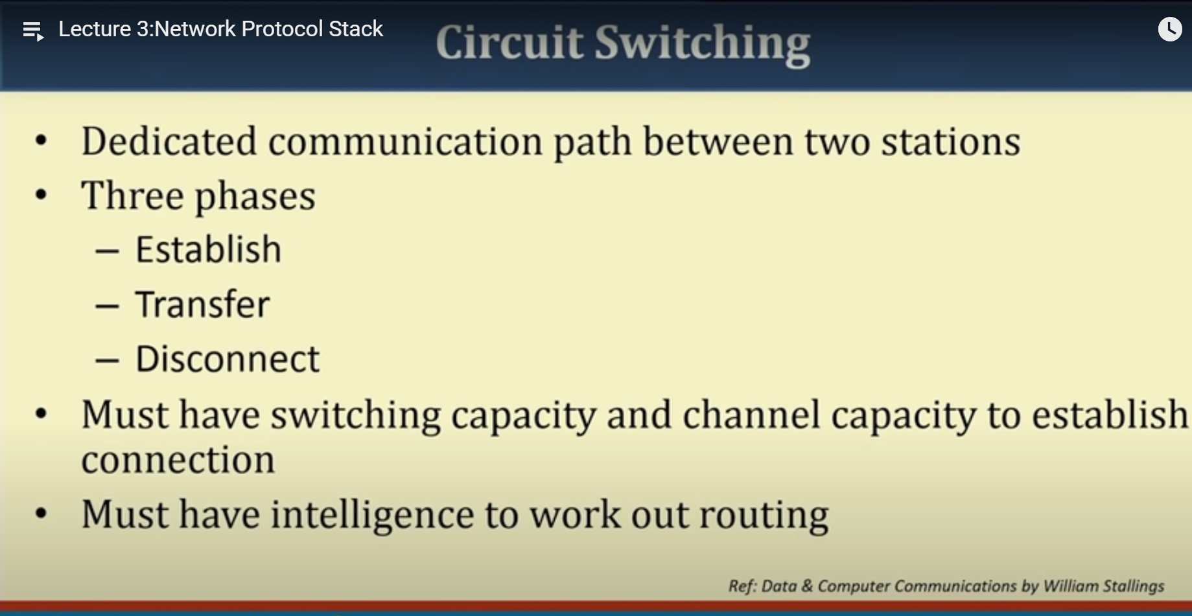



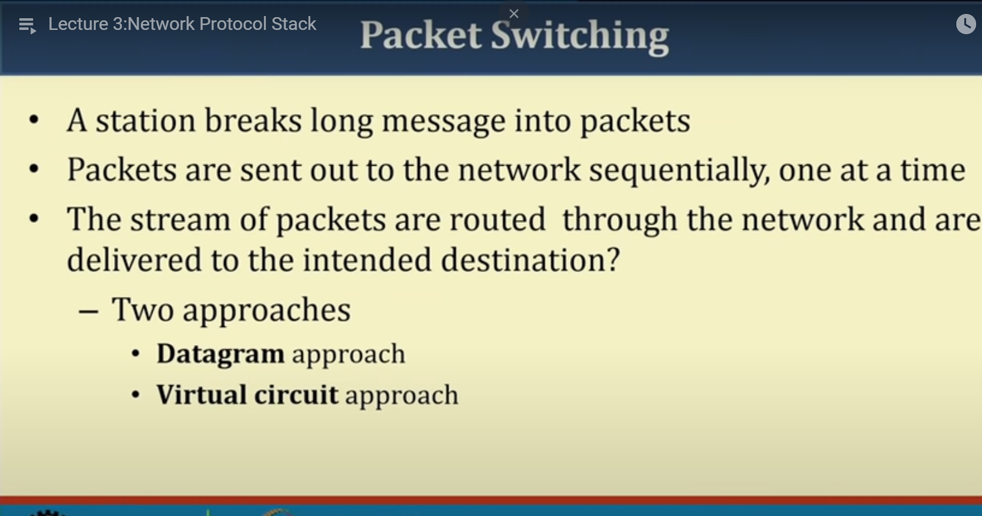

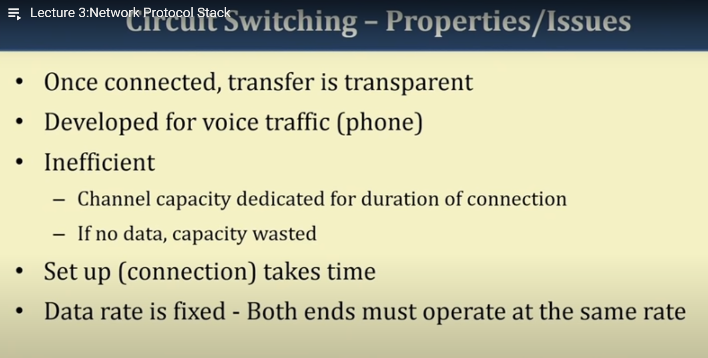

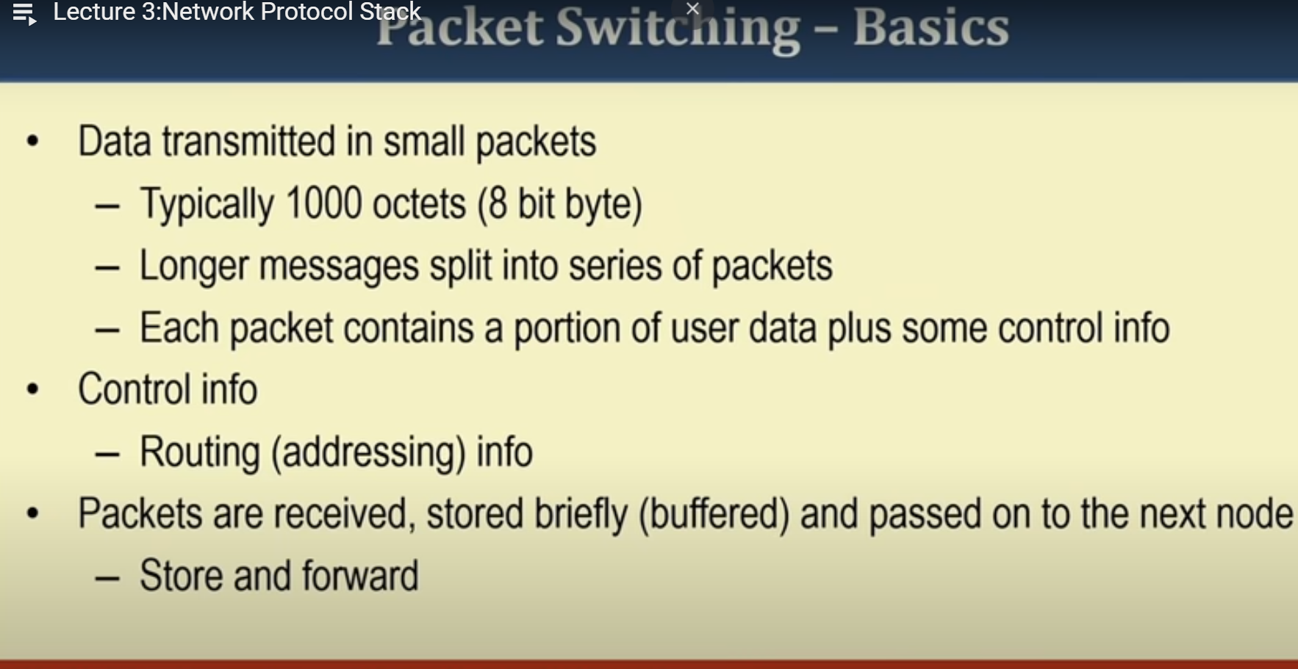

In packet switching packets can be given priority.

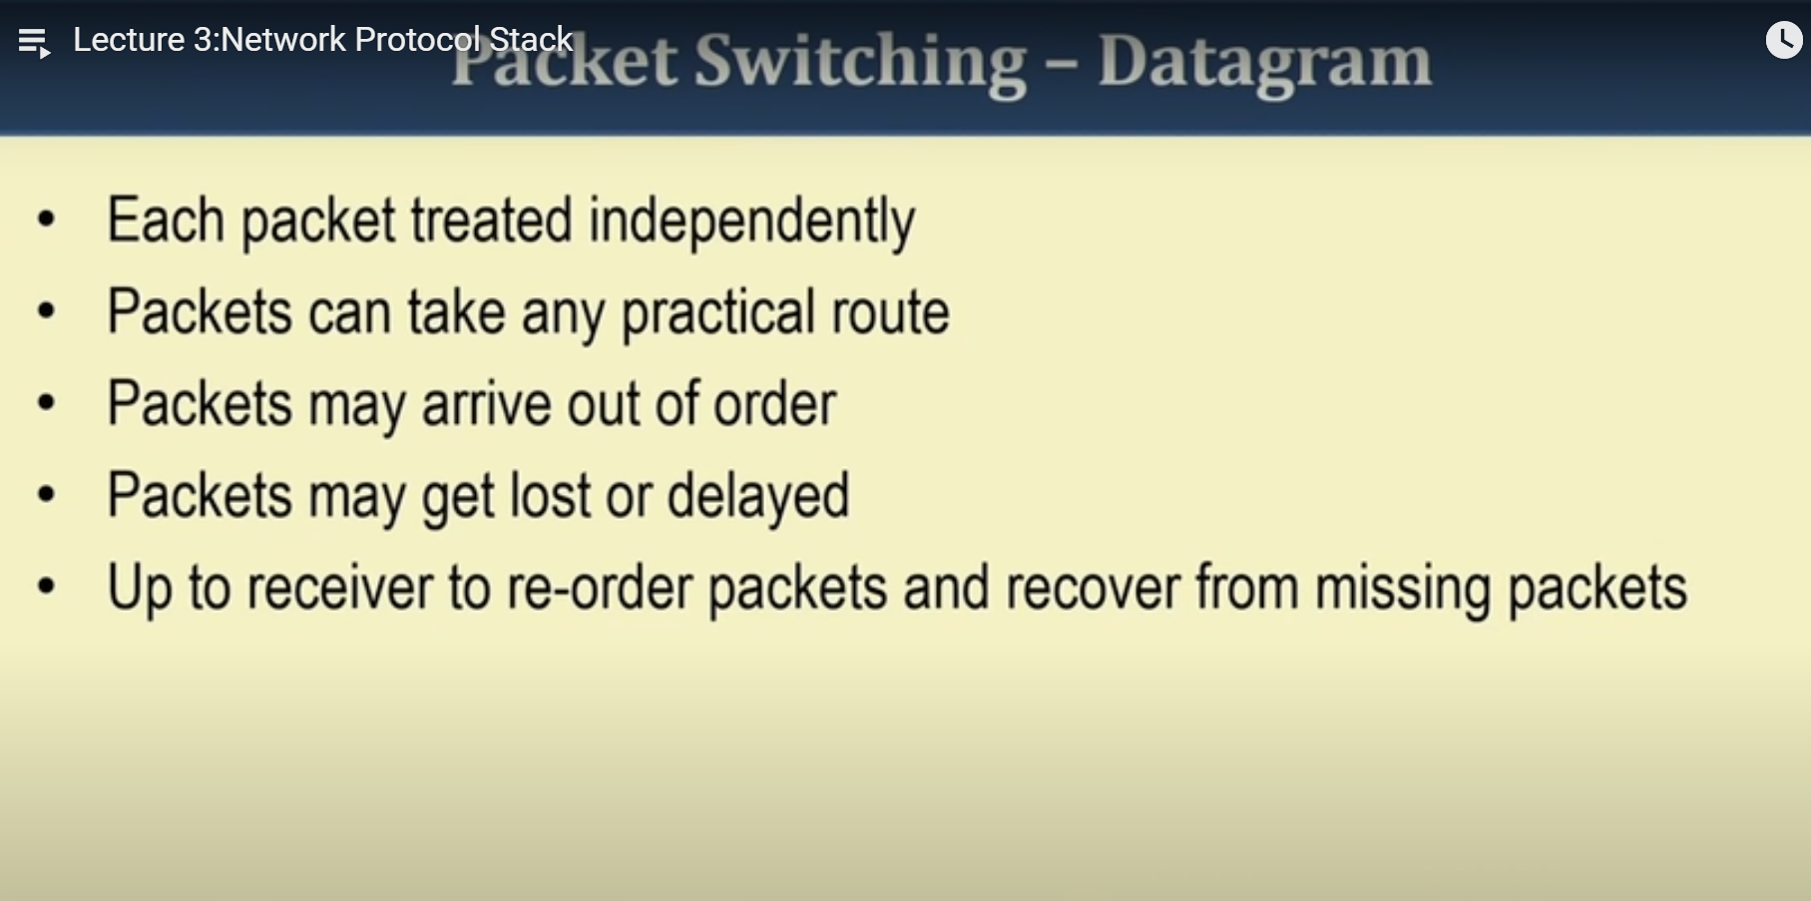

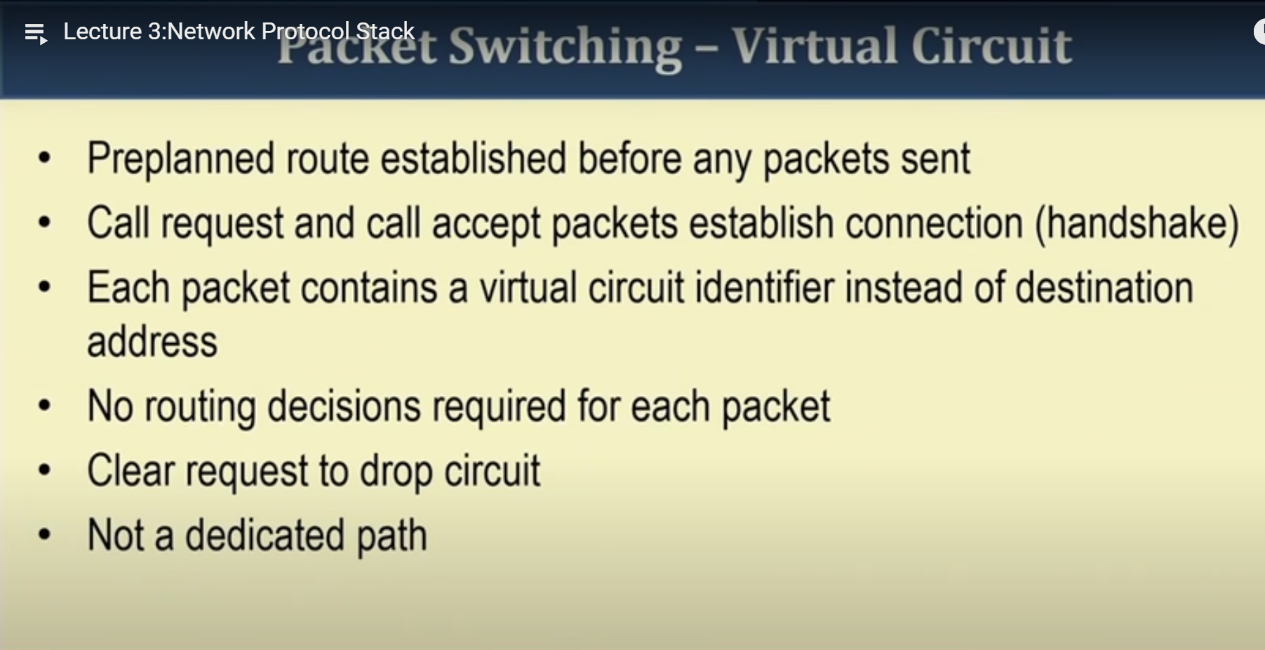

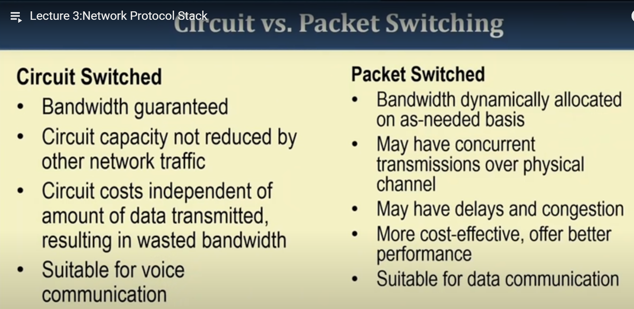

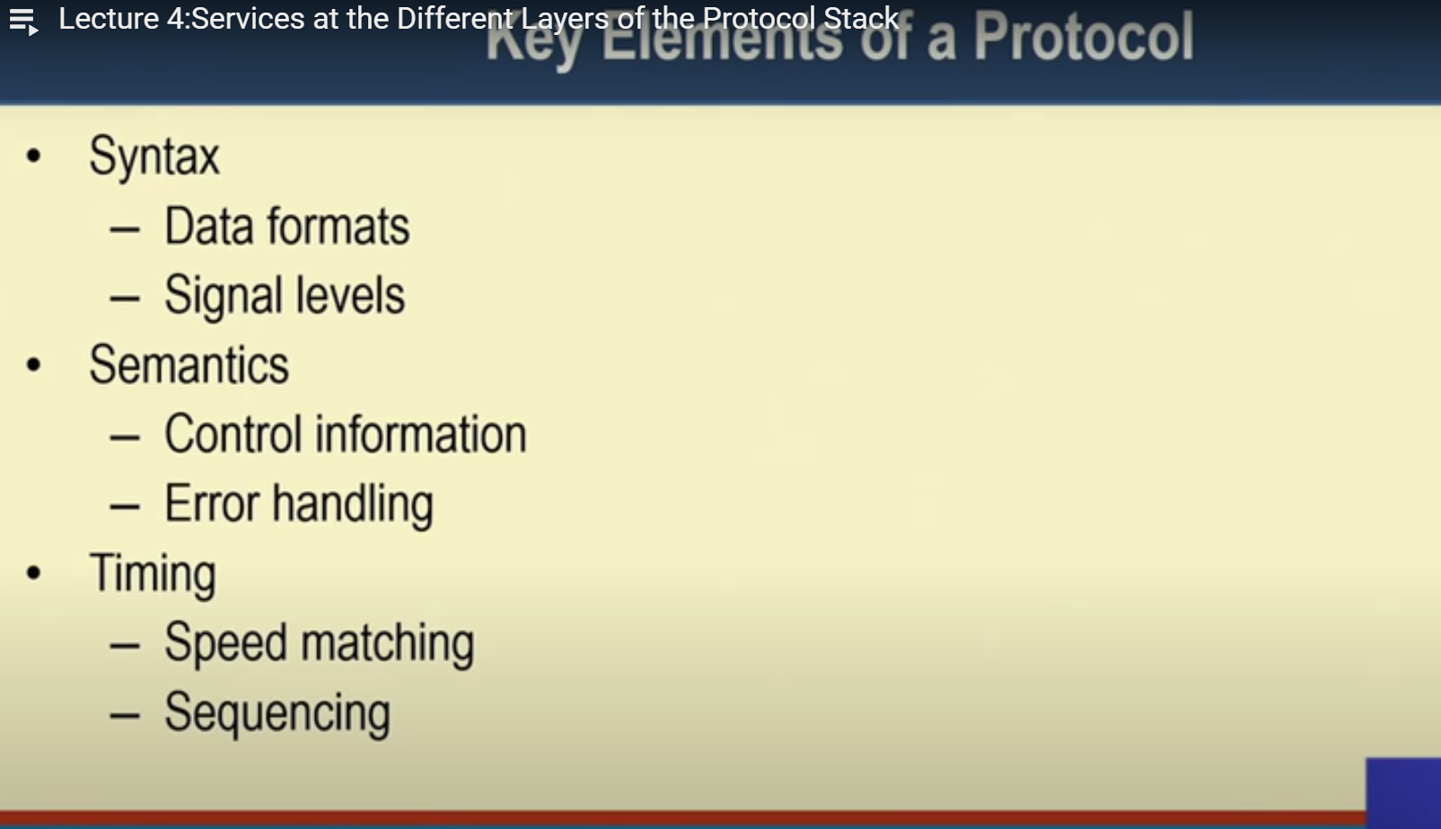

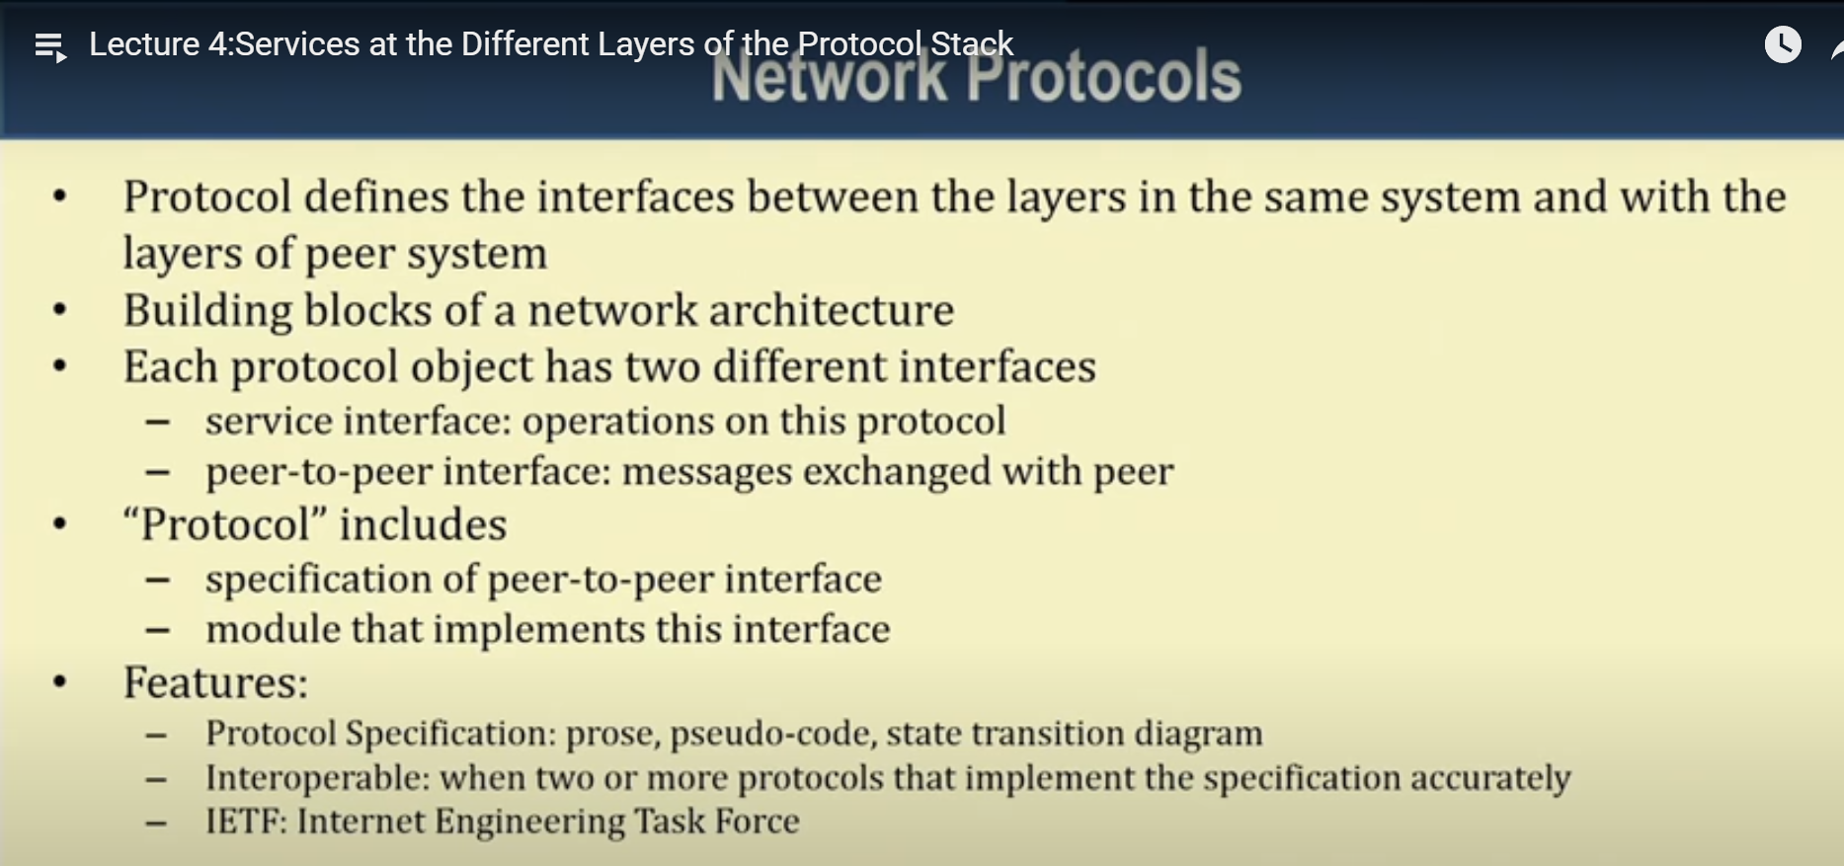

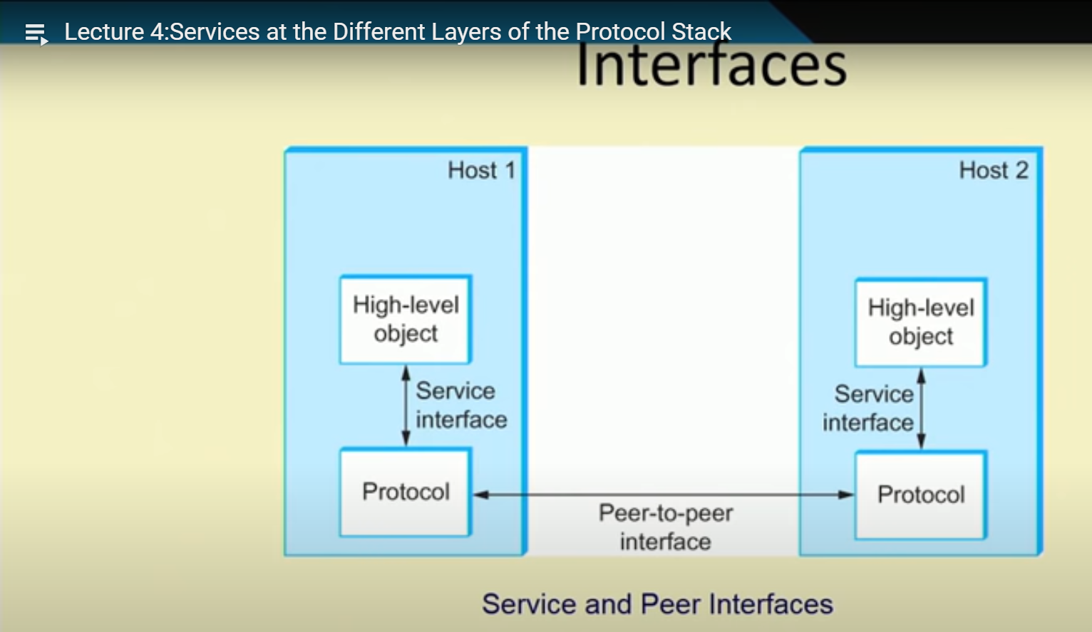

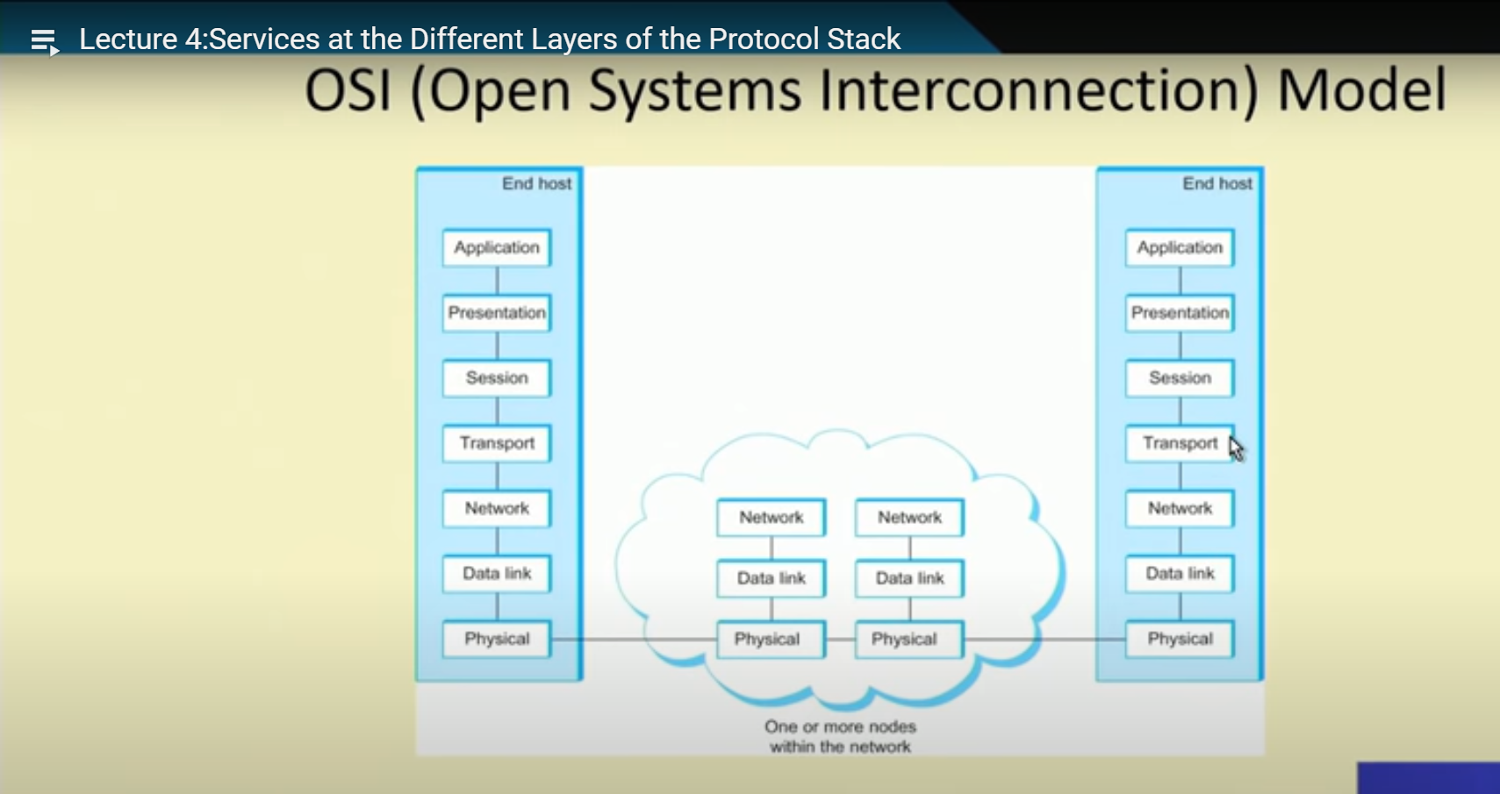

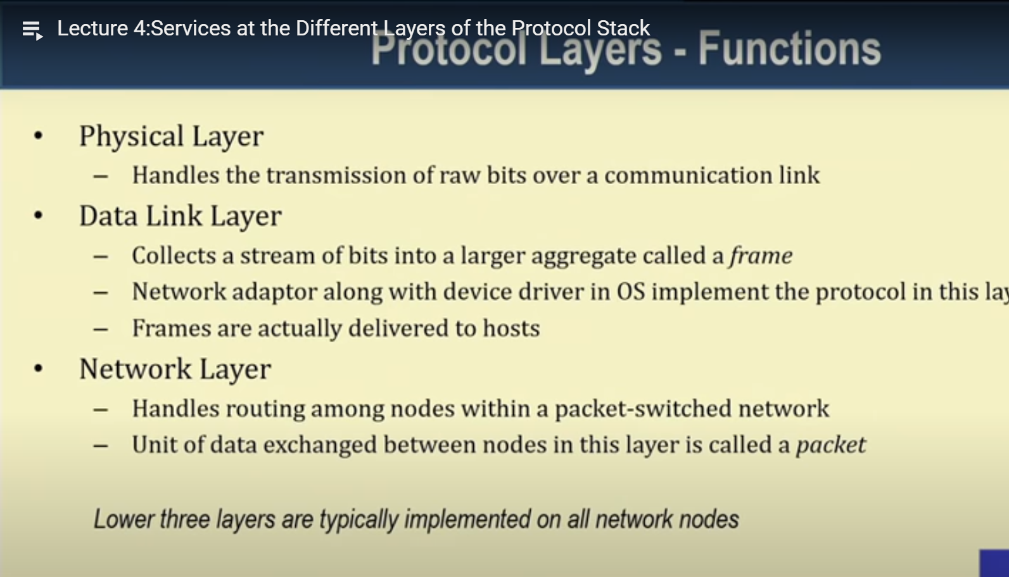

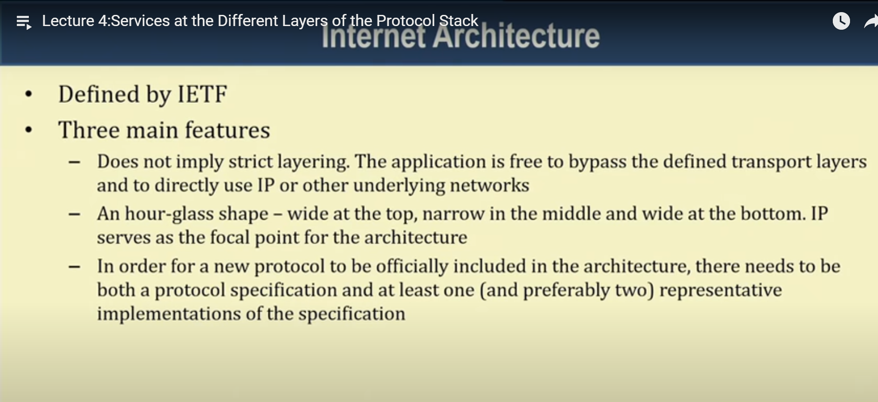

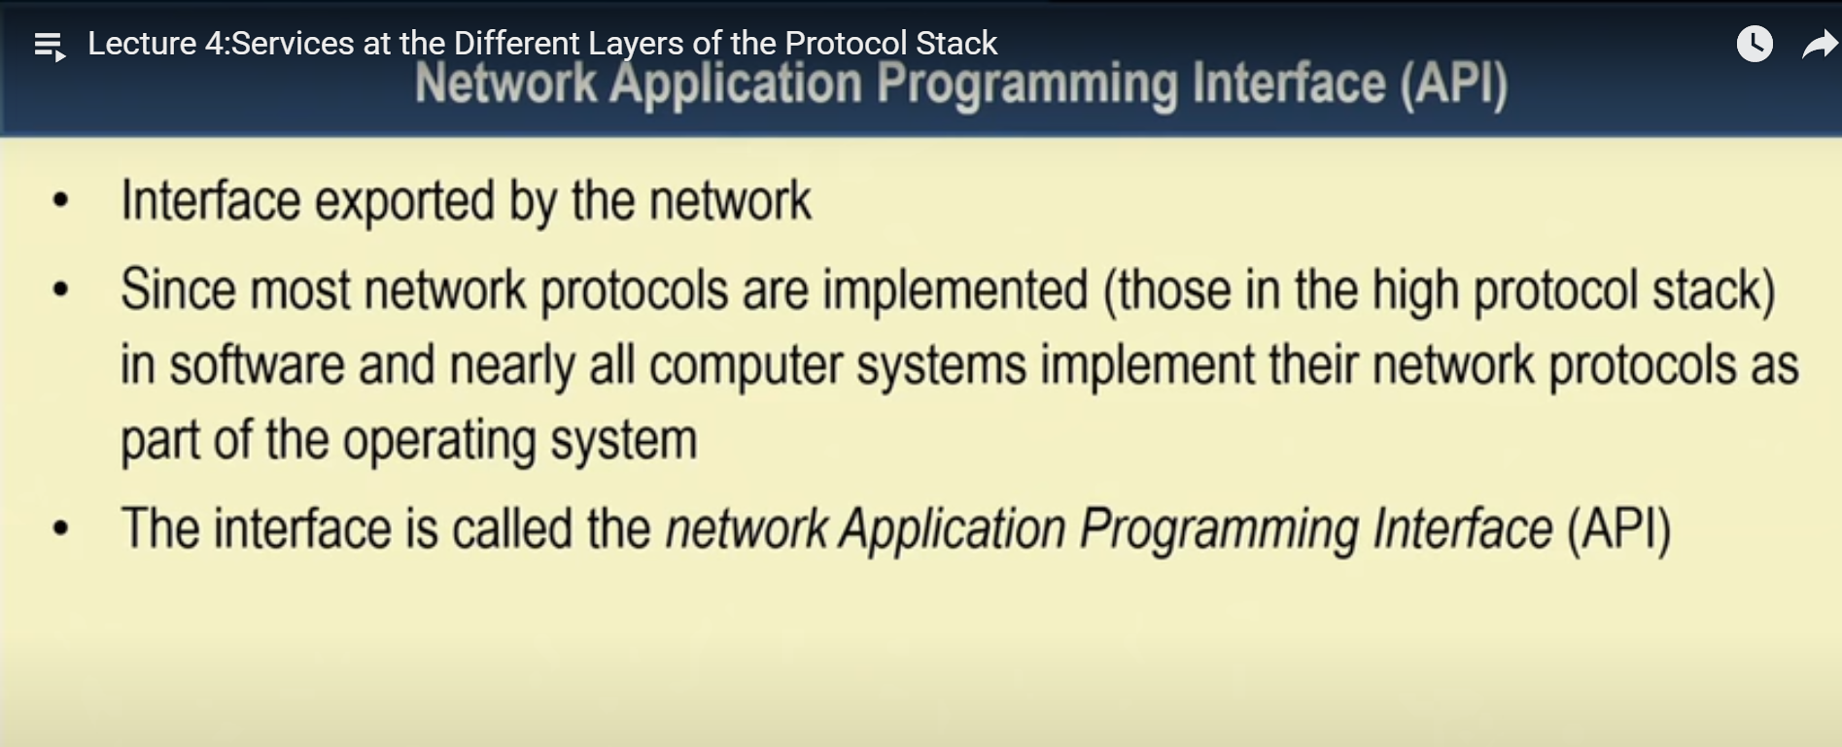

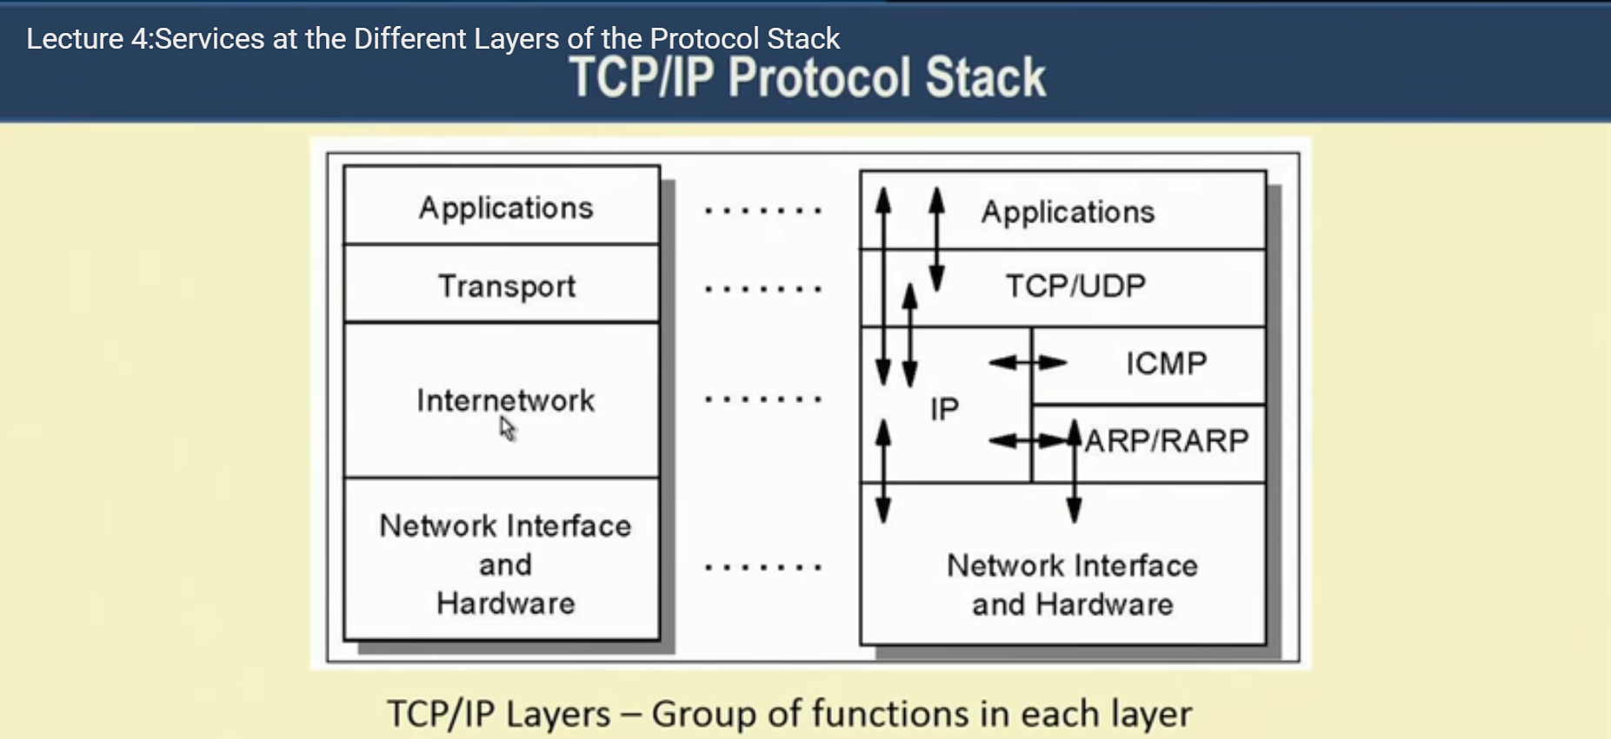

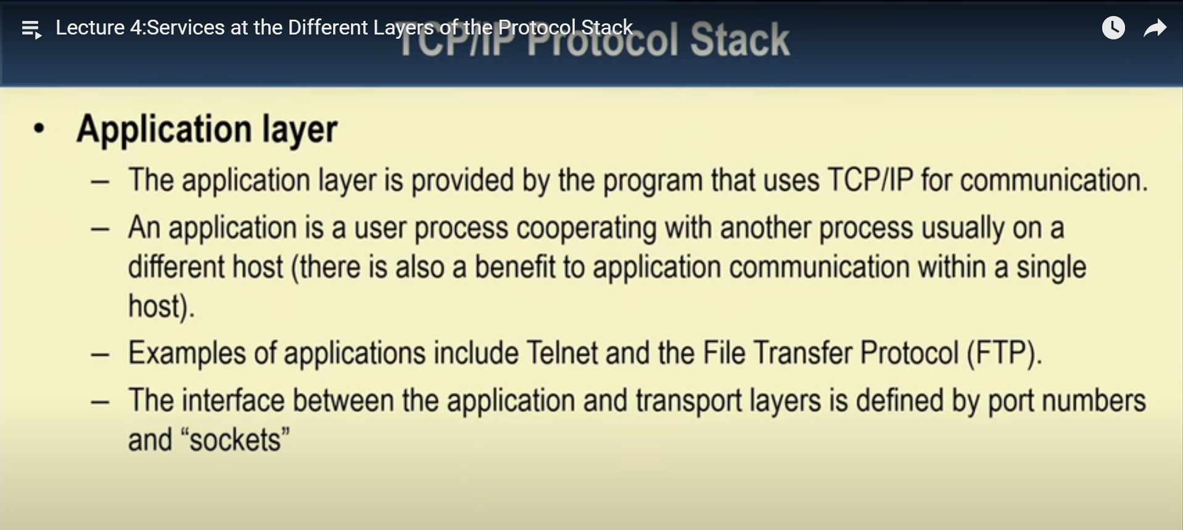

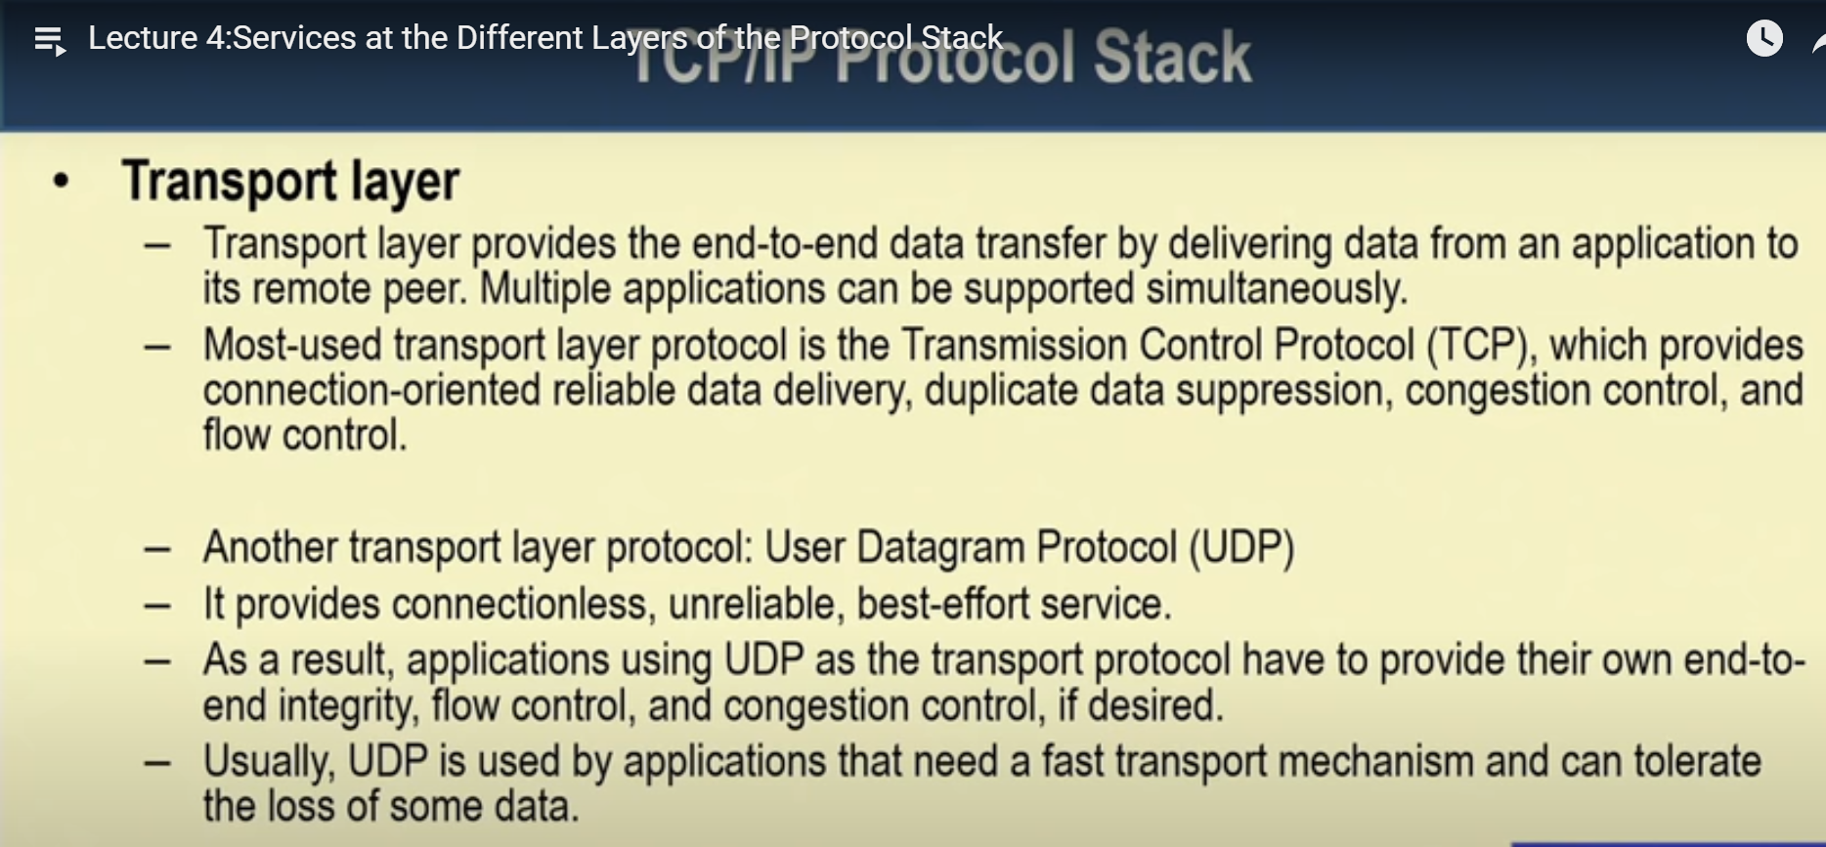

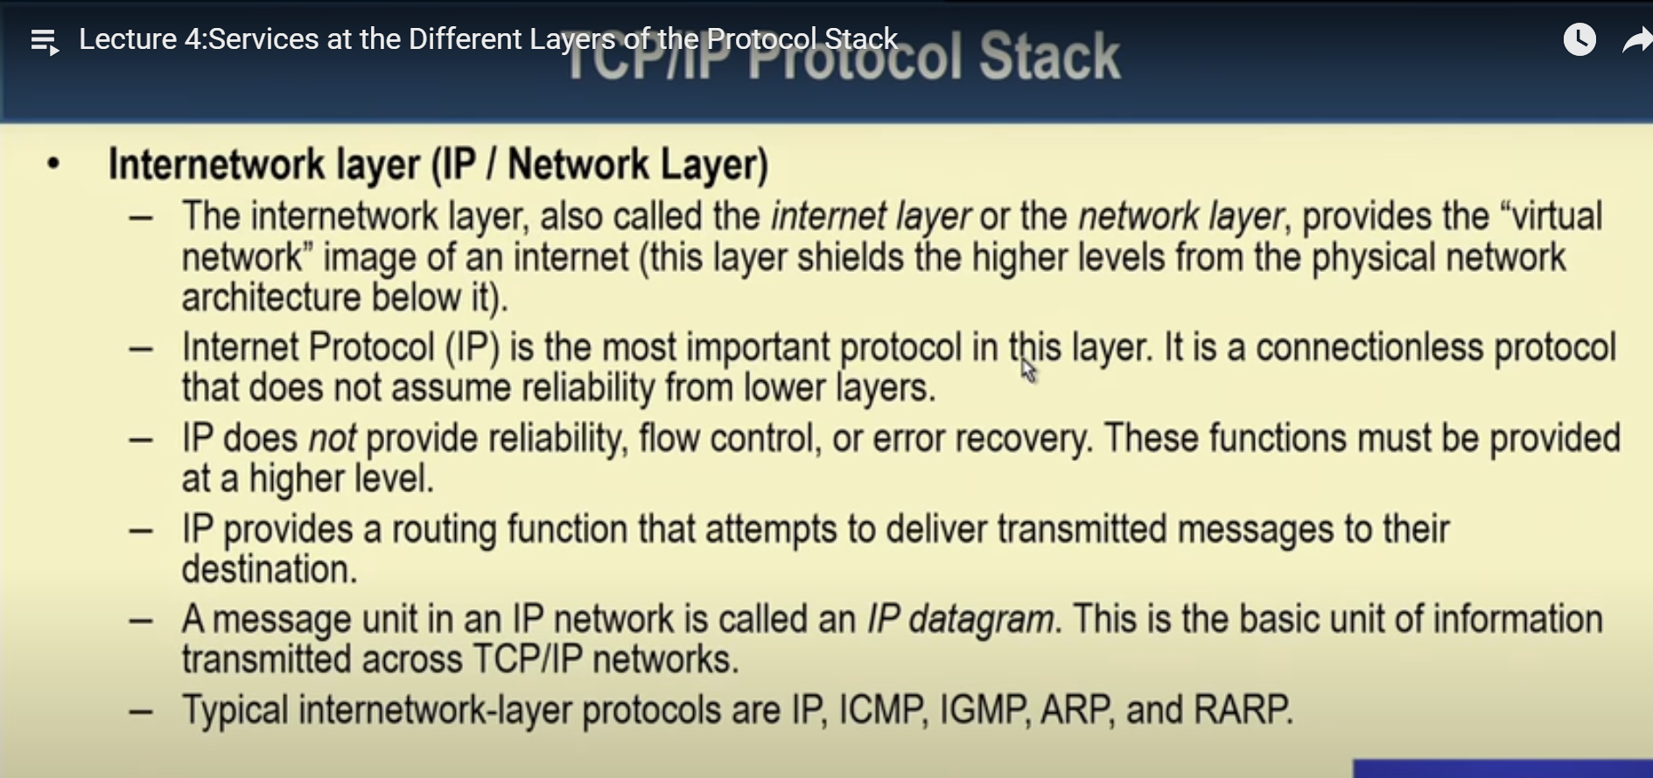

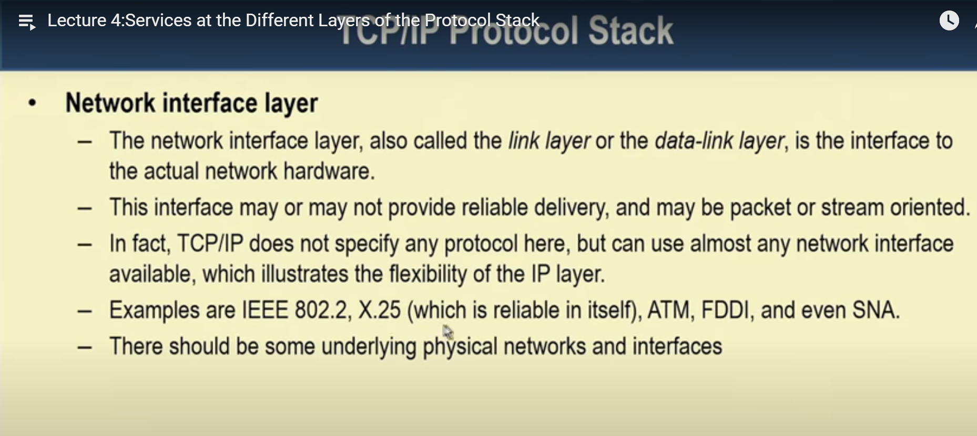

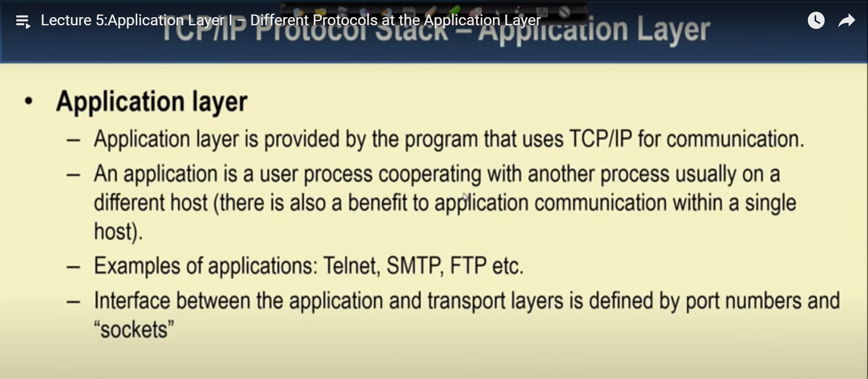

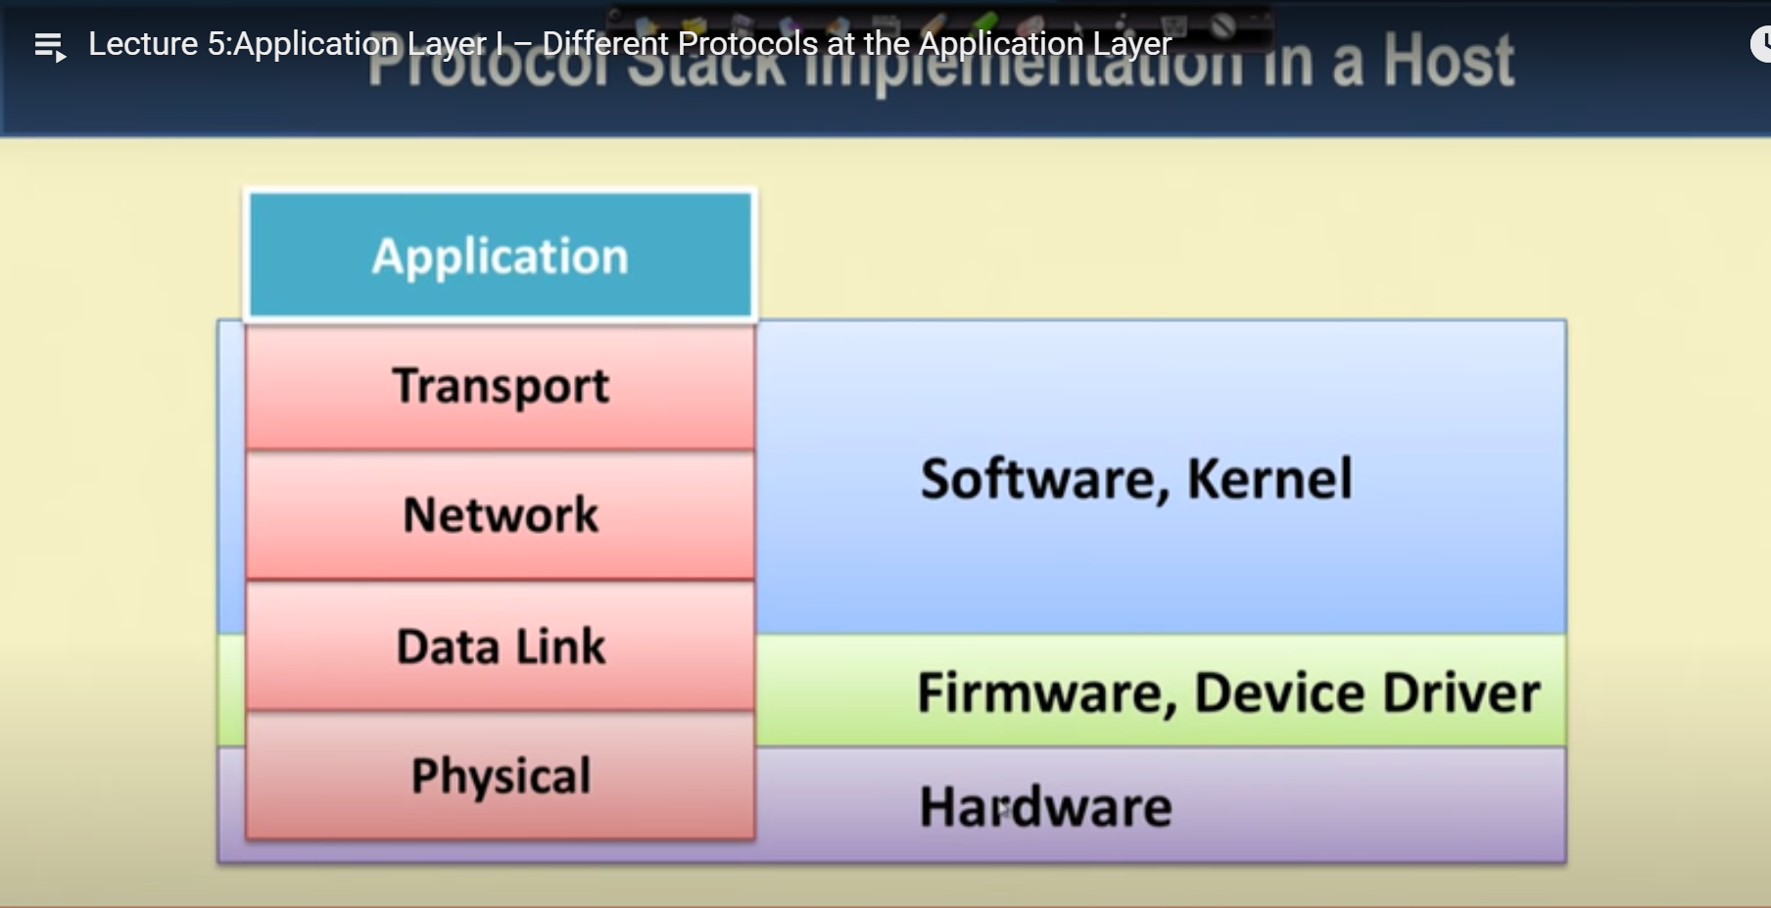

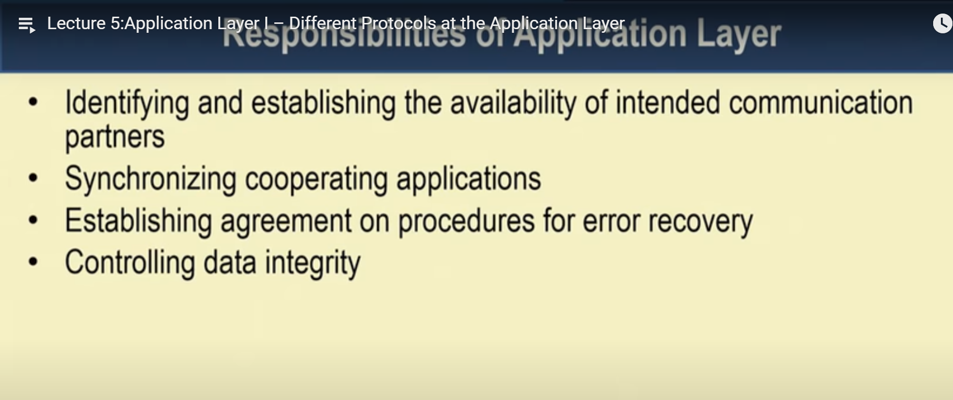

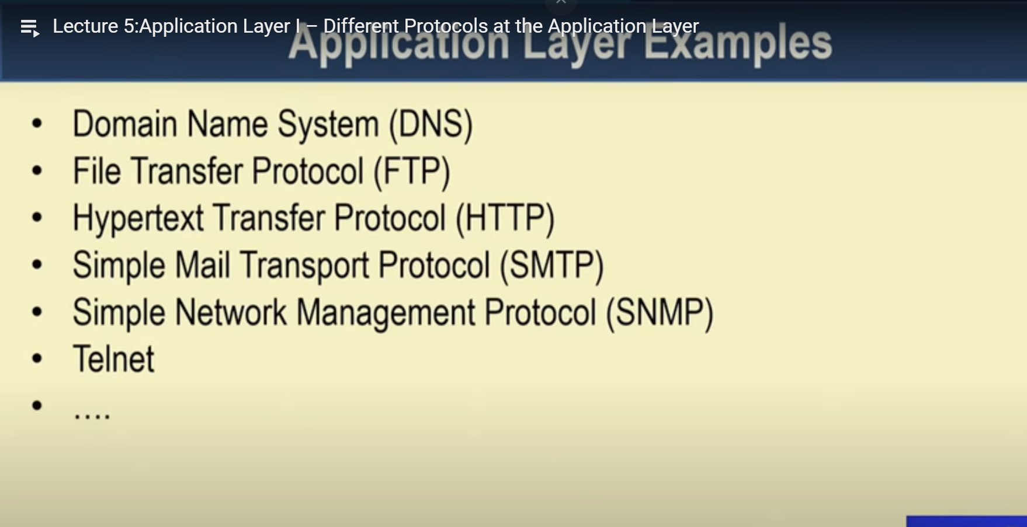

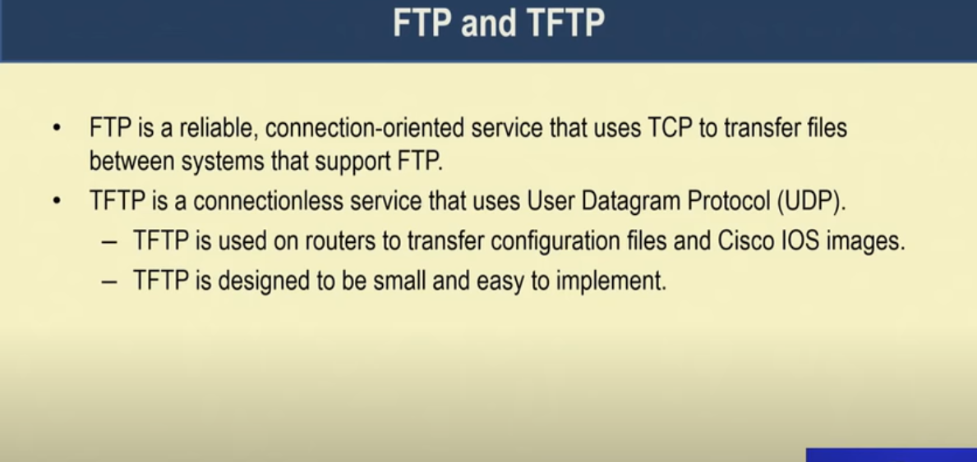

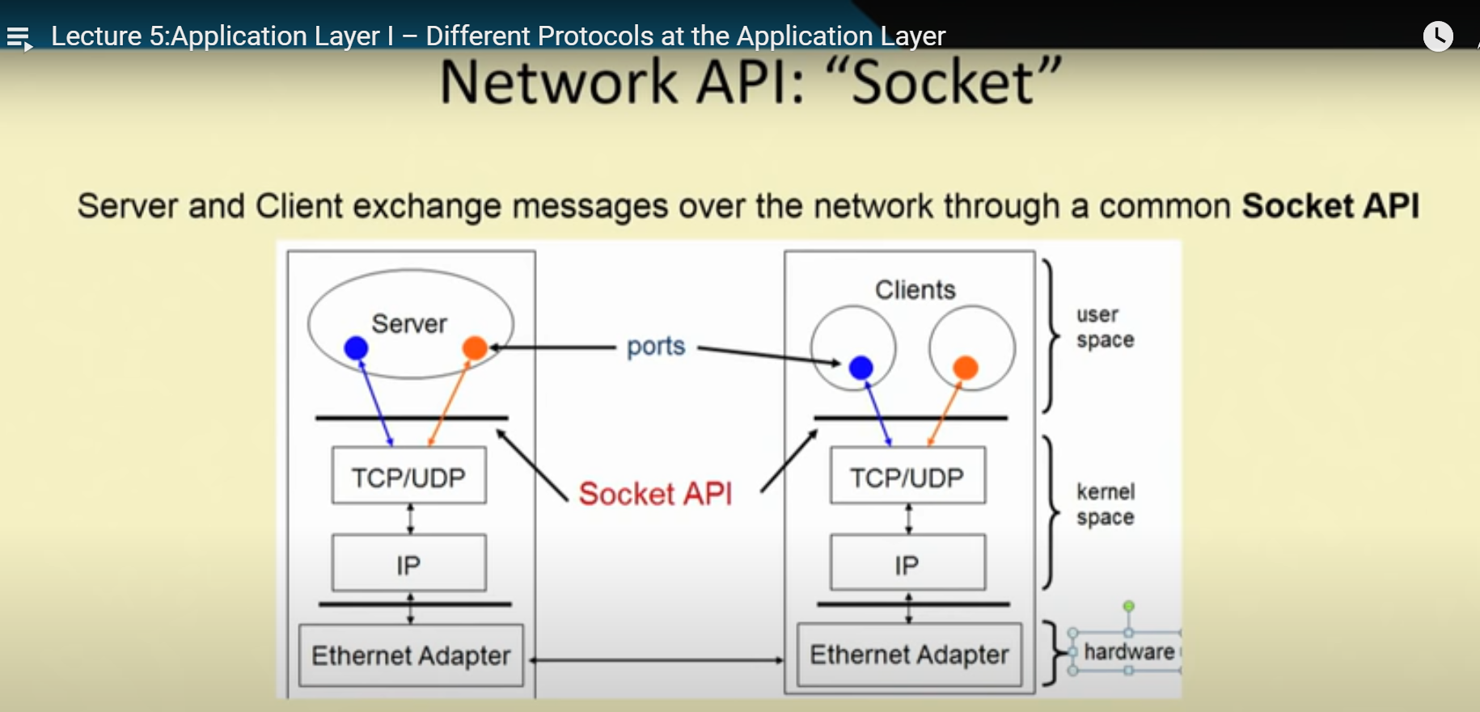

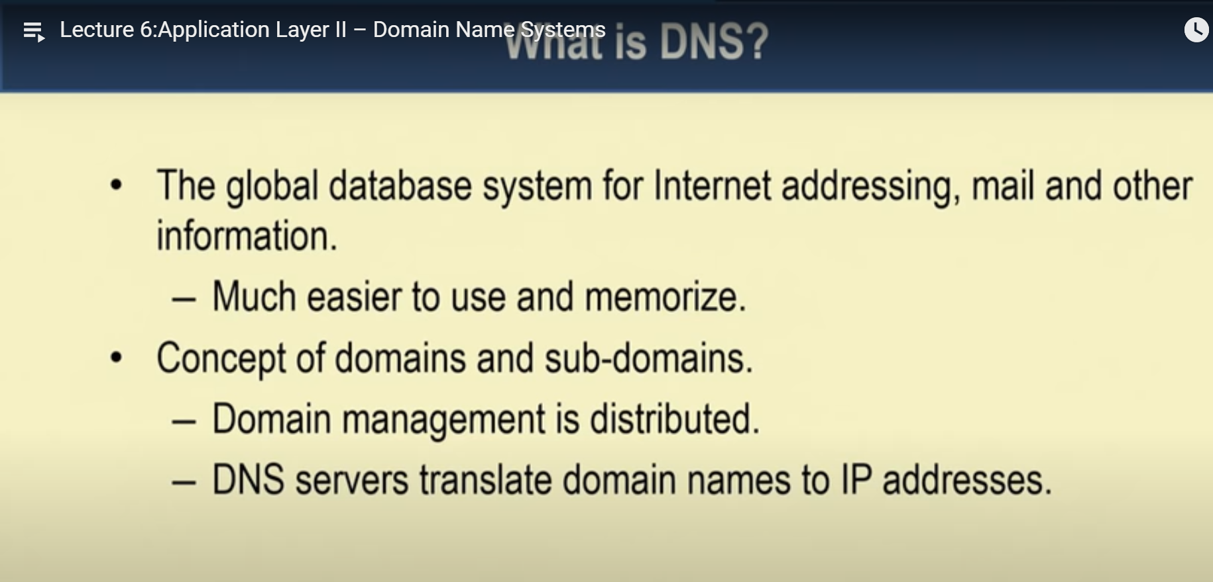

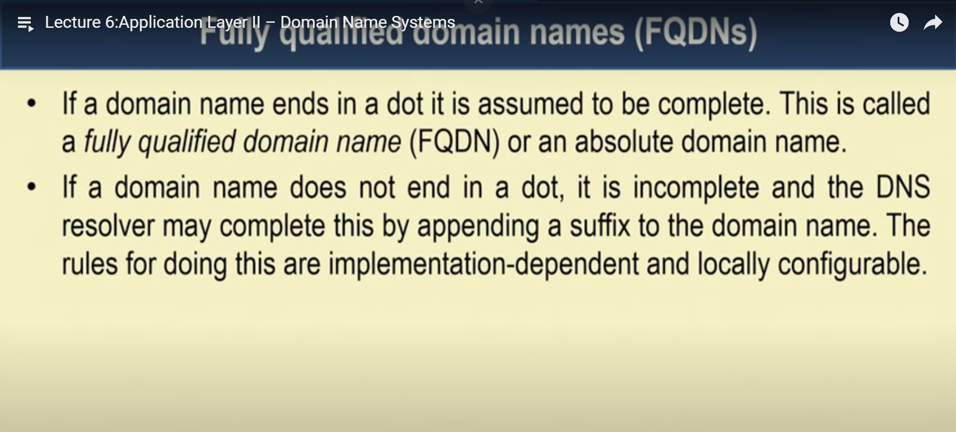

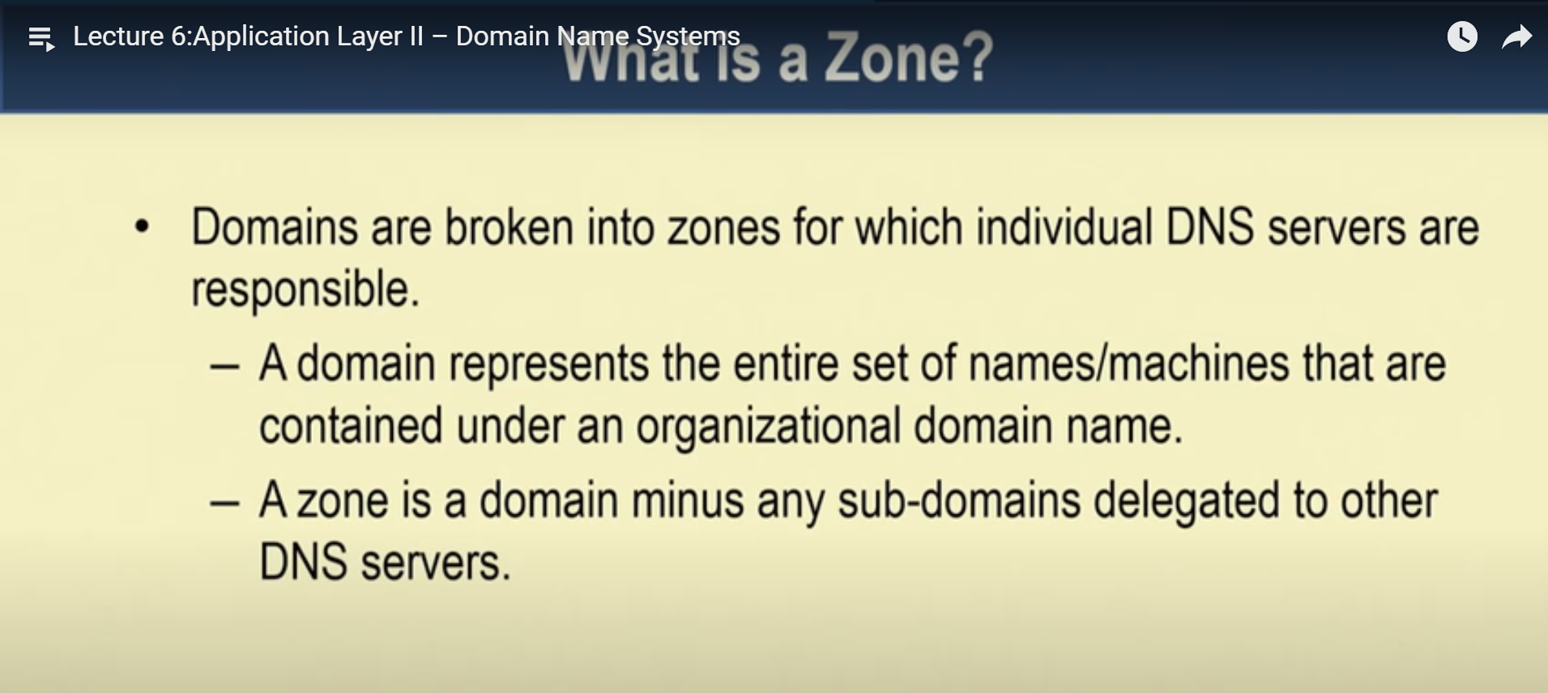

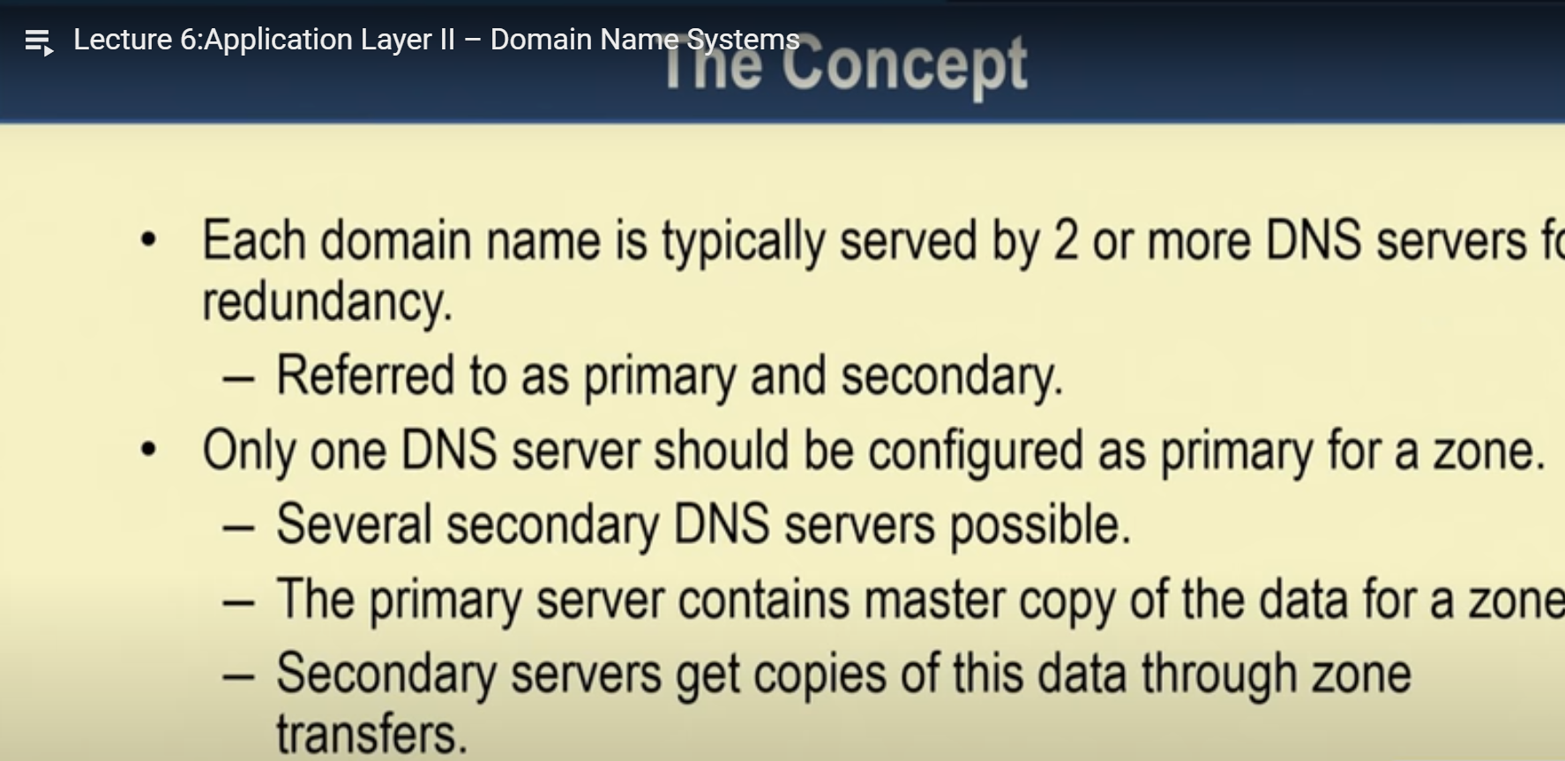

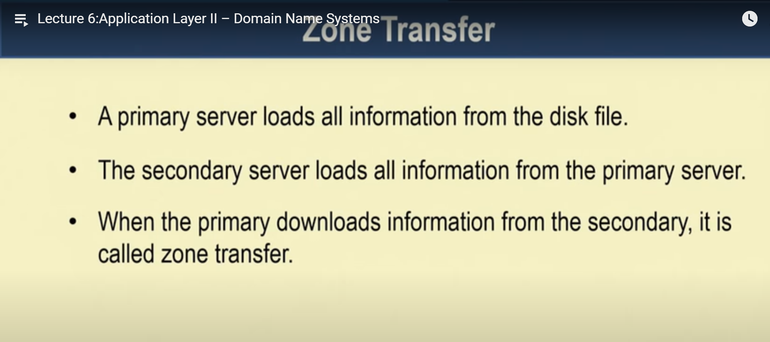

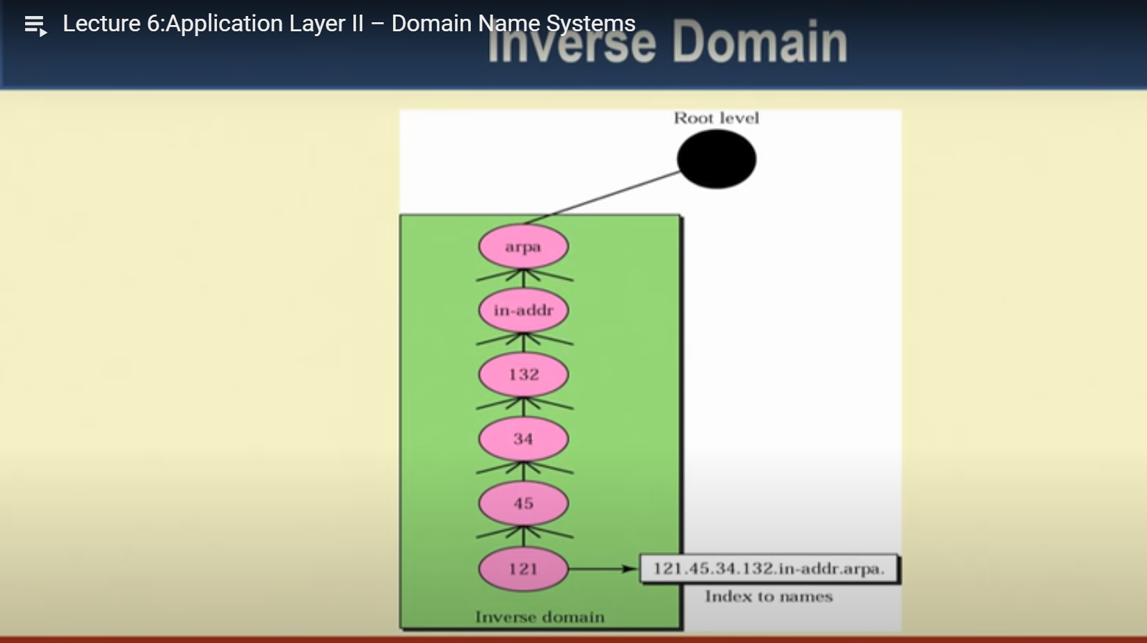

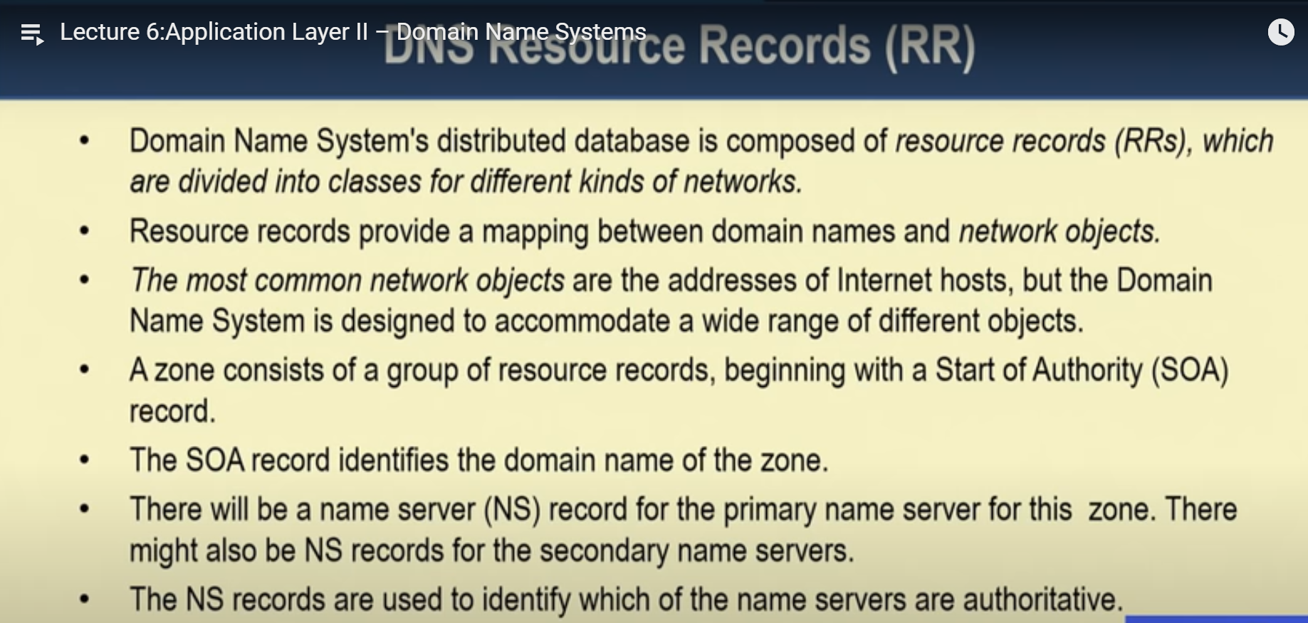

Study Iterative, recursive, name resolution from iitk website.

<https://www.cse.iitk.ac.in/users/dheeraj/cs425/lec23.html>

<https://www.cse.iitk.ac.in/users/dheeraj/cs425/lec22.html>

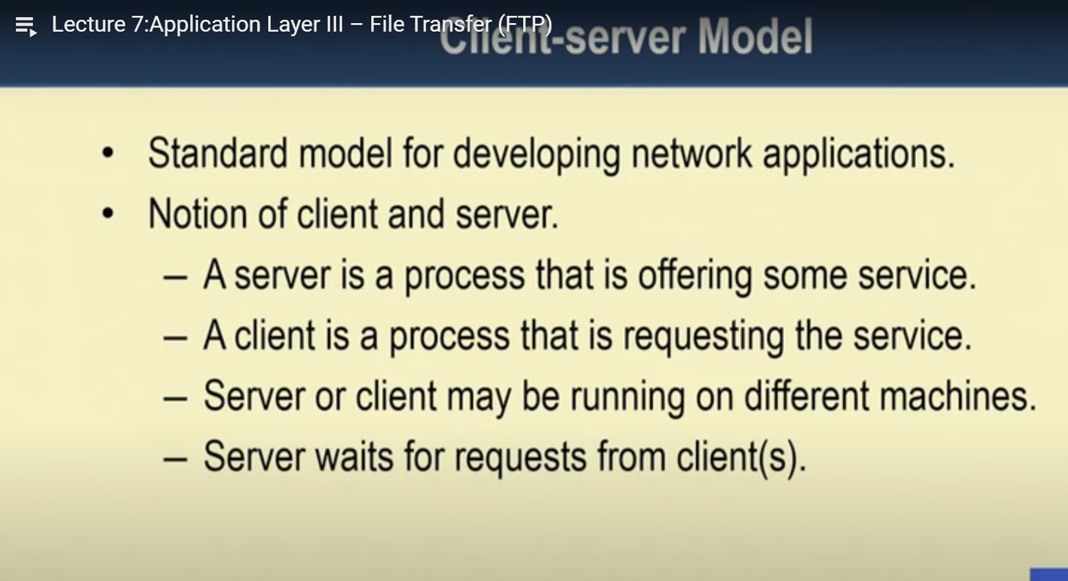

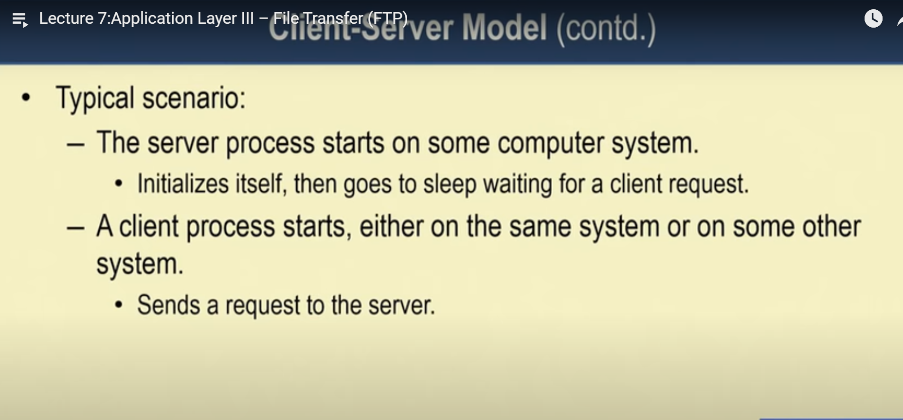

Study Iterative and concurrent server.

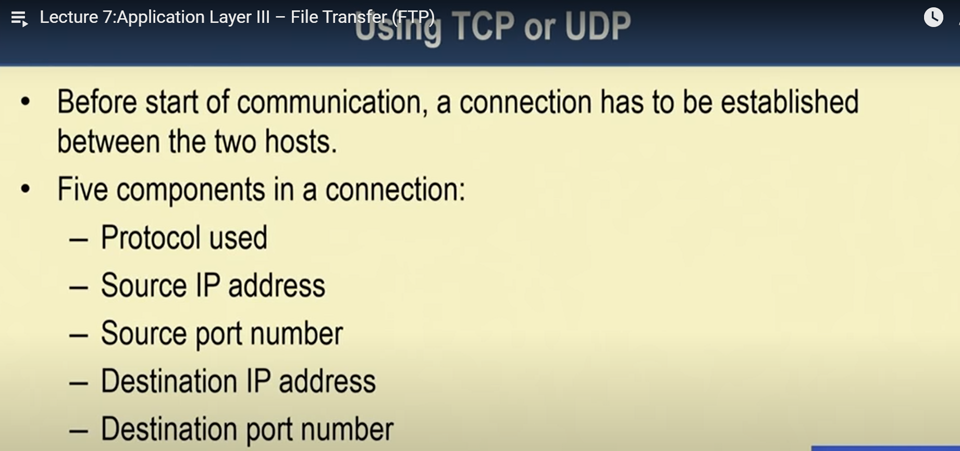

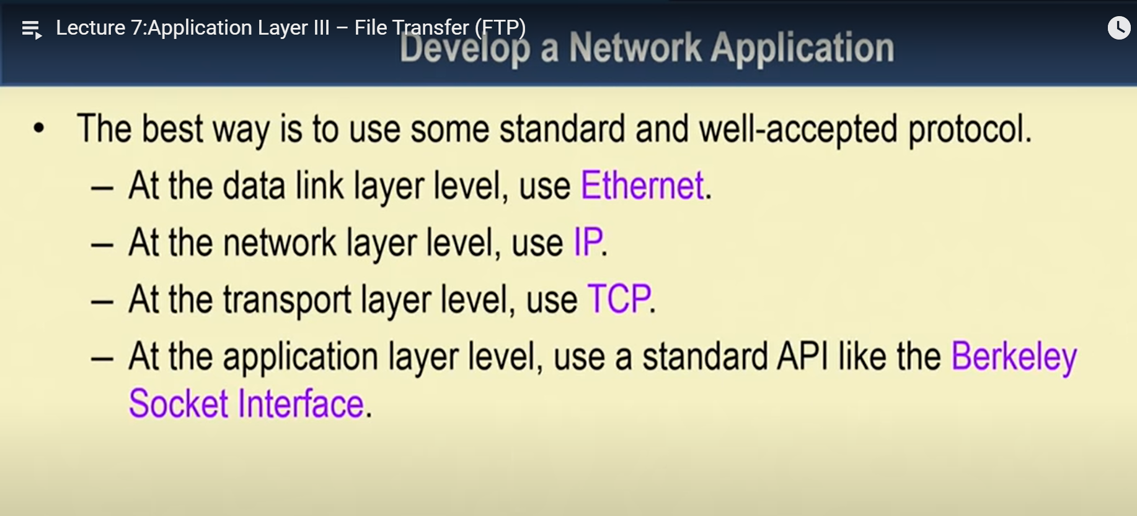

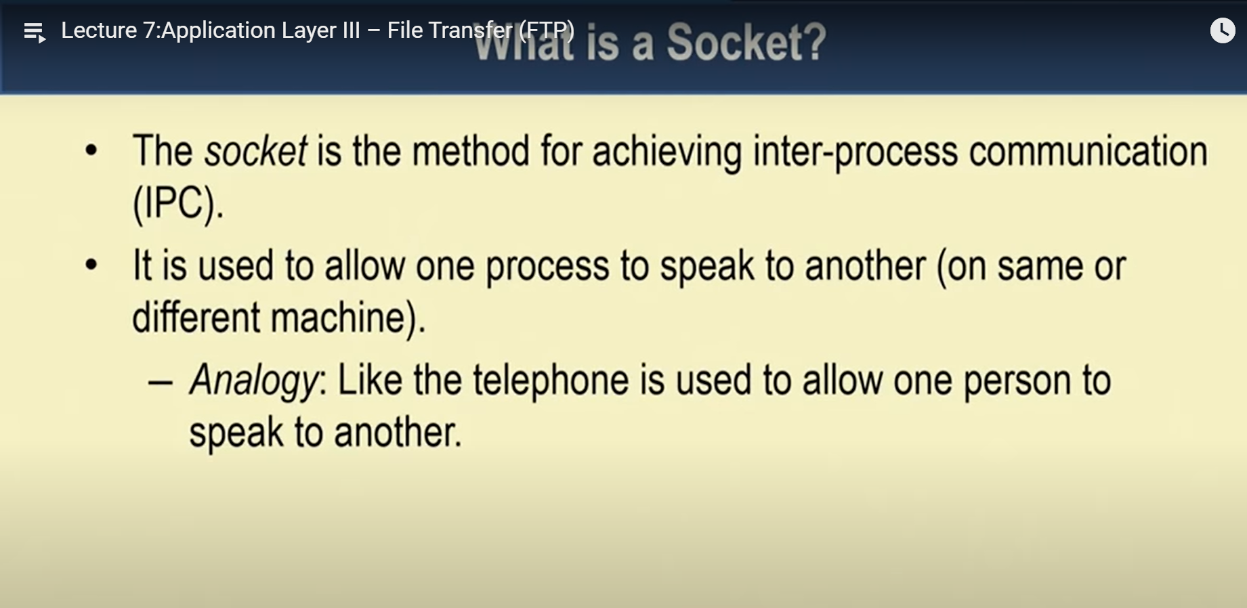

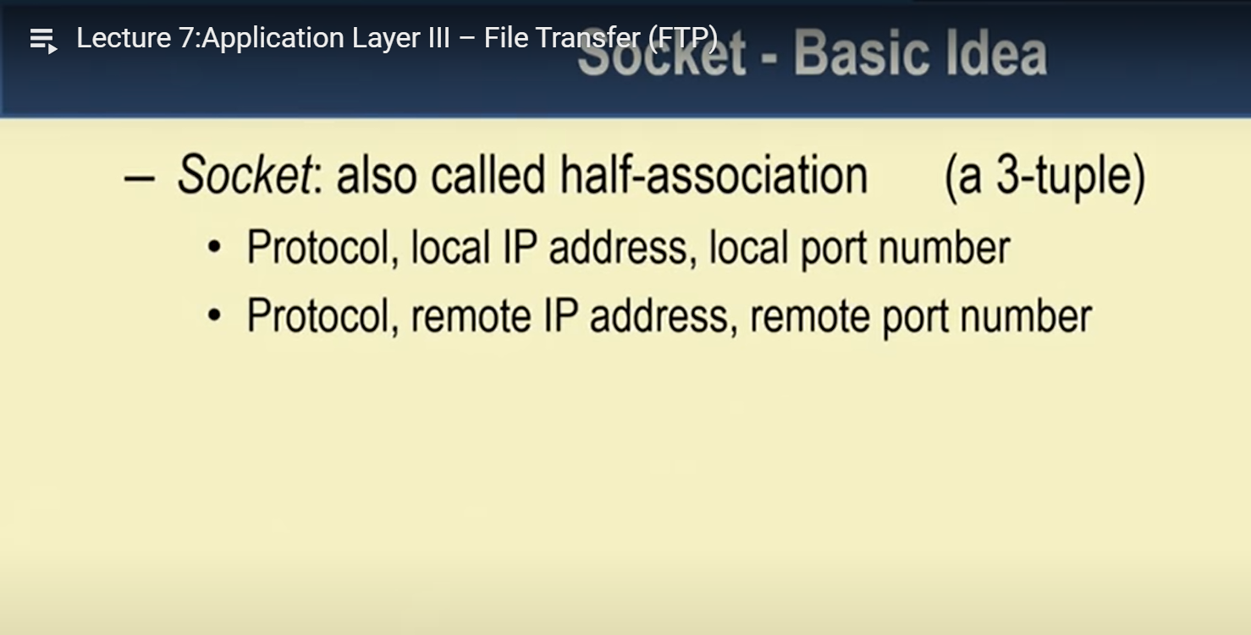

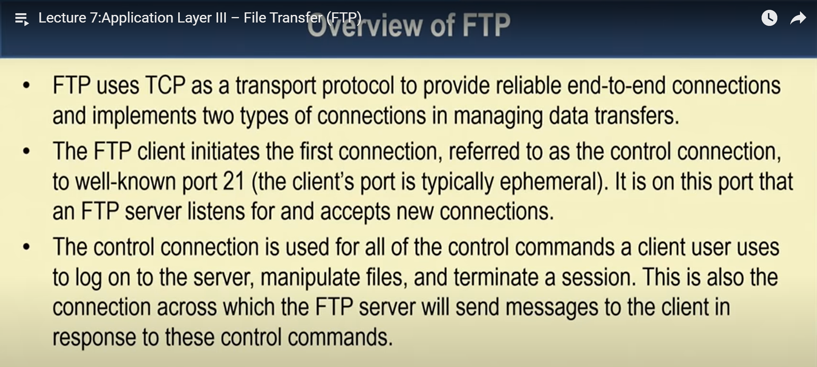

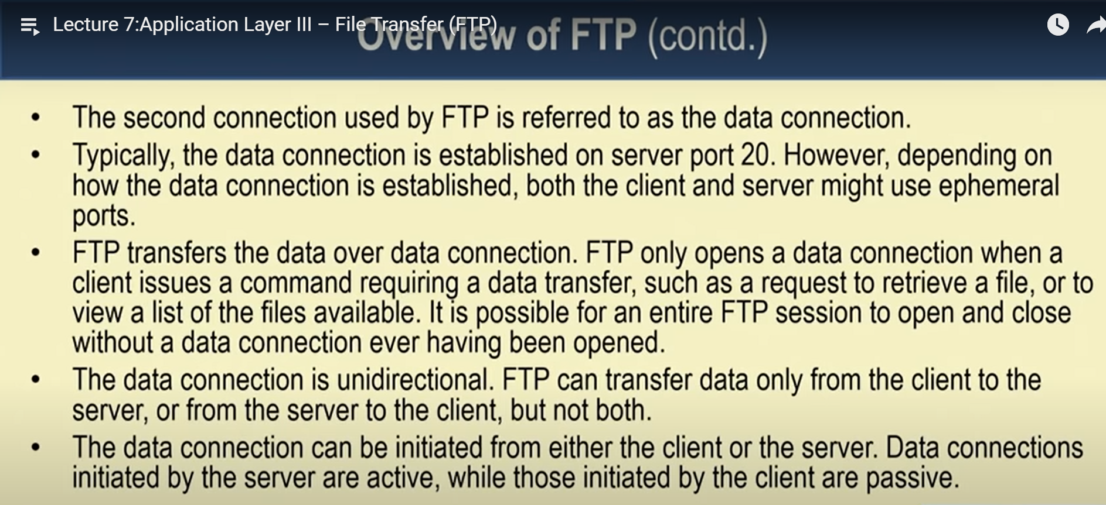

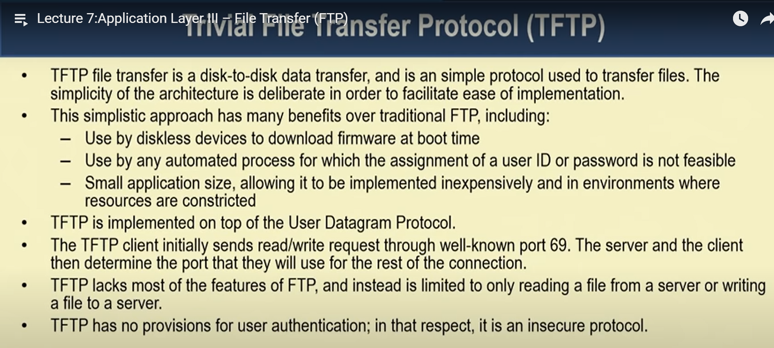

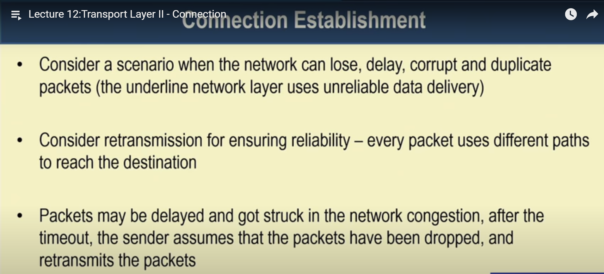

<https://www.geeksforgeeks.org/layers-of-osi-model/>

<https://www.imperva.com/learn/application-security/osi-model/>

A list of protocols used by a certain system, one protocol per layer, is called **protocol stack**.

**Synchronous and Asynchronous communication.**

<http://web.sonoma.edu/users/f/farahman/sonoma/courses/es465/lectures/es465_fall2010/lect_ch9.pdf>

<https://nptel.ac.in/content/storage2/courses/108105057/Pdf/Lesson-25.pdf>

A **socket** is one end-point of a two-way communication link between two programs running on the network.

<http://www2.ic.uff.br/~michael/kr1999/3-transport/3_05-segment.html> 🡪 TCP

**All internships should end by 20th June.**

**Internship report should be submitted to clg by 20th June for approval from library.**

**Bandwidth:** The range of frequencies over which most of the signal energy of a signal is contained is known as **bandwidth** or effective bandwidth of the signal.

**bandwidth** is a measurement indicating the **maximum capacity** of a wired or wireless communications link to transmit data over a network connection in a given amount of time.

***Base-band***is defined as one that uses digital signalling, which is inserted in the transmission channel as voltage pulses.

On the other hand, ***broadband***systems are those, which use analog signalling to transmit information using a carrier of high frequency